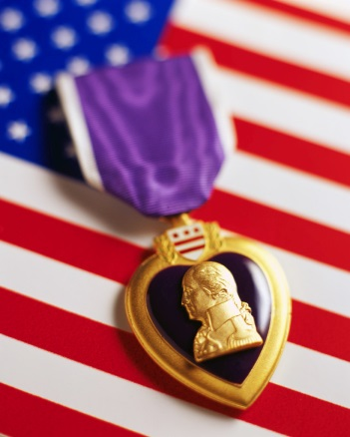

Discounts to
Purple Heart Recipients
CONSERVATION PATRON LICENSE
Residents and non-residents who have received the Purple Heart can now purchase a conservation patron license for a discounted price. Gov. Scott Walker signed a bill in law allowing in state Purple Heart recipients to buy a conservation patron license for $10 (normally $165) and non-resident Purple Heart recipients to purchase the license for $161 (normally $600). Non-resident Purple Heart recipients can also purchase individual hunting, fishing and trapping licenses at in-state rates.
The conservation patron license is one license that includes a wide variety of hunting, fishing, trapping and other state licenses. The reduced fee conservation license does not include a subscription the Wisconsin Natural Resources magazine.
Purple Heart recipients who wish to receive the reduced fee license need to provide documentation to the Department of Natural Resources service center showing that the Purple Heart Medal was awarded to the customer.
Several DNR service centers are listed below for your convenience. Please call them for specific hours & requirements.
Dane County: 3911 Fish Hatchery Rd, Fitchburg, WI 53711 (608) 275-3266
Dane County: 101 S Webster St, Madison, WI 53703 (608) 266-2621
Iowa County: 1500 N Johns St, Dodgeville, WI 53533 (608) 935-3368

Discounts to
Purple Heart Recipients
PURPLE HEART PASS
The Purple Heart is unique among military awards, in that the criterion for the award is very objective: You must be wounded during action with an enemy of the United States.
While clearly an individual decoration, the Purple Heart differs from all other decorations in that an individual is not "recommended" for the decoration; rather he or she is entitled to it upon meeting the specific criteria.
You who are recipients of the Purple Heart are indeed a special group of American veterans. There is nothing we can add to that award; it stands by itself.
The Milwaukee County's Purple Heart Pass (PHP) program was started in 2013 as a way to recognize that award by granting Wisconsin's Purple Heart recipients a free pass to some of Milwaukee County's world class attractions.
Milwaukee County wants to recognize and honor your service and sacrifice.
The Pass will continue indefinitely. The PHP allows free admission year round for the pass holder +1 guest to:
Milwaukee County
- Harley-Davidson Museum
- Milwaukee Art Museum
- Milwaukee Public Museum
- Milwaukee County Zoo
- Discovery World
- Whitnall Park Boerner Botanical Gardens
- Mitchell Park Domes
Brown County
- Neville Public Museum
- Brown County NEW Zoo
- Green Bay Botanical Gardens
- Green Bay Gamblers Games
- Blizzard football games
- Brown County Golf Course (9 holes/season)
- Green Bay Packer Hall of Fame
Clark County
- Highgrounds Veterans Memorial Park in Neillsville, free tours to the pass holder and guests.
Manitowoc County
- Wisconsin Maritime Museum in Manitowoc, free admission year-round to the pass holder and one guest
Buffalo County
- Elmer's Auto and Toy Museum in Fountain City, free admission to the pass holder and one guest (open weekends only, May through September)
The Milwaukee County Veterans Service Office (MCVSO) will administer the pass, verifying eligibility through military service records. Purple Heart Veterans can contact MCVSO Director Jim Duff via phone (414-266-1235) or email (jduff@milwcnty.com) for more information on obtaining a pass. Applications can also be obtained from your local County Veterans Service Office.

