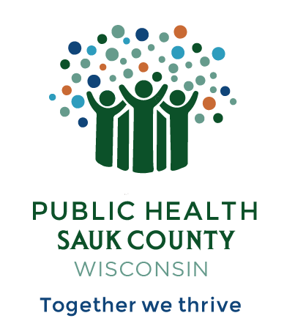
Public Health Sauk County
505 Broadway Street, Suite 372
Baraboo, WI 53913
Telephone: (608) 355-3290 Fax: (608) 355-4329

For immediate release July 24, 2026
Contact: Hannah Erdman, Health Educator
Public Health Sauk County
(608)-355-4319
Hannah.erdman@saukcountywi.gov

Free Recovery-Friendly Community Event at Devil’s Lake on July 28th
Sauk County, Wis -- On Tuesday, July 28, 2026, from 10 AM - 4 PM, two Sauk County groups will host a free recovery-friendly community event at Devil’s Lake State Park. The event is family-friendly, alcohol and drug-free, and is open to all Sauk County residents. It will be held on the South Shore of Devil’s Lake State Park in the White Oak shelter.
Public Health Sauk County and Sauk County Justice, Diversion, and Support Programs are proud to host this event in partnership with the Support People and Empower Recovery (SUPER) coalition. By bringing community members together through free, alcohol and drug-free activities, the organizations hope to strengthen community connections and support the health and well-being of all Sauk County residents.
"We're working to create more opportunities for people to connect in healthy, welcoming spaces," explains Hannah Erdman, Health Educator with Public Health Sauk County and facilitator of the Support People and Empower Recovery (SUPER) coalition. "Whether you're coming with family, friends, or on your own, this event is a chance to enjoy one of Wisconsin's most beautiful state parks while building connections with others in our community."
Activities are planned throughout the day, starting at 10 AM with an optional free yoga class on the beach or a guided hike. People Helping People will provide brats for lunch with sides donated by local businesses and community members. Musician Alexander Gabriel will perform live from 12 PM - 1 PM. Two people in recovery from substance use will then speak, sharing their stories of hope and resilience.
Register for this free event at bit.ly/dayatdevilslake2026.
If you have any questions, please contact Hannah Erdman at hannah.erdman@saukcountywi.gov or call/text 608-963-8467.
The event is sponsored by Sauk County Justice, Diversion, and Support Programs, the Support People and Empower Recovery (SUPER) coalition, and Public Health Sauk County. Bill Harris from People Helping People in Baraboo and other local businesses are generously donating food and beverages.

About Public Health Sauk County
Public Health Sauk County supports the well-being of all people in our community. Through wellness programs, environmental health initiatives, and a focus on creating systemic change, we cultivate healthier places and people so that Sauk County can thrive. For more information on our programs and services, visit https://www.co.sauk.wi.us/publichealth.
###

