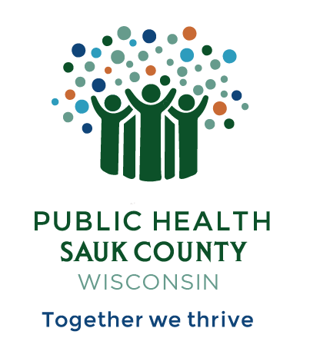
Public Health Sauk County
505 Broadway Street, Suite 372
Baraboo, WI 53913
Telephone: (608) 355-3290 Fax: (608) 355-4329

For immediate release July 6, 2026
Contact: Dr. Jennifer Weitzel, Health Officer
Public Health Sauk County
608-355-3290 jennifer.weitzel@saukcountywi.gov

Public Health Sauk County Opens Nominations for 2026 Public Health Excellence Awards
Sauk County, Wis— Public Health Sauk County invites nominations for the 2026 Public Health Excellence Awards, a recognition program for the community. These awards honor people and groups who help improve the health and well-being of Sauk County residents and visitors.
Public Health Sauk County encourages community members to nominate local health champions who deserve recognition for their work. These awards celebrate people and organizations who solve health problems, keep others safe, and make Sauk County a better place to live, learn, work, and play.
"The positive response to our first-ever awards ceremony exceeded all expectations," says Dr. Jennifer Weitzel, Health Officer for Public Health Sauk County. "We're thrilled to continue this tradition and honor even more outstanding contributions to our community's health with a new set of categories this year."
Award Categories:
- Public Health Lifetime Achievement Award
- Healthy Environments Award
- Prevention in Action Award
- Strong Starts, Stronger Futures Award
- Public Health Partnership Award
Nominations are open now through August 7th, 2026. To submit a nomination, visit https://bit.ly/PH-Awards26. Winners will be honored at a special ceremony in the fall.

About Public Health Sauk County
Public Health Sauk County supports the well-being of all people in our community. Through wellness programs, environmental health initiatives, and a focus on creating systemic change, we cultivate healthier places and people so that Sauk County can thrive. For more information on our programs and services, visit https://www.co.sauk.wi.us/publichealth.
###

