
Public Health Sauk County
505 Broadway Street, Suite 372
Baraboo, WI 53913
Telephone: (608) 355-3290 Fax: (608)355-4329

For immediate release May 20, 2026
Contact: Rebecca Szydlowski, Public Health Nurse
Public Health Sauk County
(608) 355-4337 Rebecca.Szydlowski@saukcountywi.gov
Public Health Sauk County Holds Rural Safety Day Camp
Nearly 700 third-grade students participated in this year's Rural Safety Day Camp, held May 12–14 at the Sauk County Fairgrounds. Led by Public Health Sauk County and a dedicated committee of local professionals, the three-day event guided students through interactive stations and presentations covering thirteen safety topics.
This year's camp welcomed two new topics, e-bike and scooter safety and first aid, along with returning favorites like chemical, fire, electrical, firearm, water, animal, bike, seat belt, farm equipment, and electrical safety.
"This event has deep roots in our community, and that shows in the support we receive year after year," says Rebecca Szydlowski, Public Health Nurse and Rural Safety Days Coordinator. "Our local businesses and organizations give so generously of their time and resources, and that commitment is what keeps this program going strong."
While Rural Safety Days is one of Safe Kids Sauk County’s more notable efforts, coalition members work hard throughout the year to promote injury prevention. Some of their year-round work includes providing free safety items such as car seats and bike helmets, as well as attending other community events to share valuable safety education related to each organization’s area of expertise.
Sponsors and partners include Allen Steele Company, Inc., Alliant Energy, Baraboo Fire and EMS District, Baraboo FFA, Baraboo Police Department, Baraboo School District Indoor Pool, Compeer Financial, Culver's, Dental Associates of Baraboo, Farm & Fleet of Baraboo, Gerike Farms, Hartje Lumber, Inc., Hill-Dale Veterinary Hospital, Jay's Ag and Turf, Lakeside Foods, Lands' End, Meyer Oil & LP, Morning Glory Veterinary Care, Public Health Sauk County, Reedsburg FFA, River Valley FFA, Sauk County Association for Home and Community Education, Sauk County Emergency Management, Sauk County Farm Bureau, Sauk County Humane Society, Sauk County Sheriff's Department, Sauk County UW Extension, Sauk Prairie FFA, Sauk Prairie Healthcare, Sauk Prairie Healthcare Foundation, Slama Equipment, SSM Health, the Wisconsin Department of Natural Resources, the Wisconsin Department of Transportation, Wisconsin Metals of Reedsburg, and the Wisconsin Poison Center (1-800-222-1222).
For more information about the Rural Safety Days Camp, Safe Kids Sauk County, or resources specific to Sauk County, please visit https://www.co.sauk.wi.us/publichealth/safe-kids or contact Rebecca Szydlowski at rebecca.szydlowski@saukcountywi.gov or 608-355-4337.
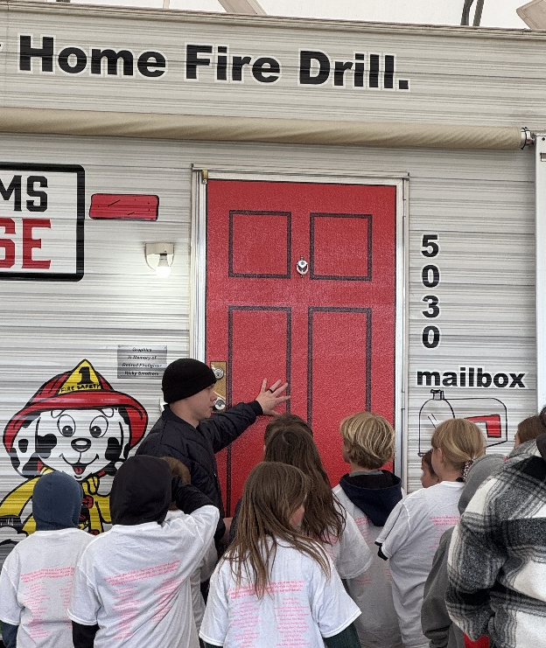
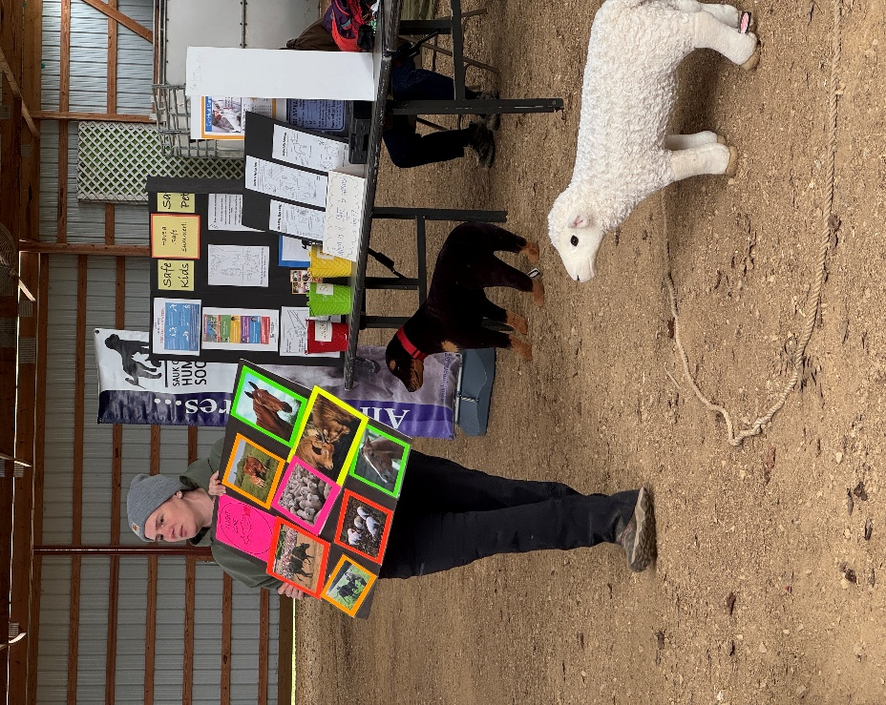
Figure 2: Baraboo Fire & EMS Assistant Chief, Josh Hecht, presenting on fire safety.
Figure 2: Dr. Marla Wilson of Morning Glory Veterinary Care
presenting on large animal safety.

About Public Health Sauk County
Public Health Sauk County supports the well-being of all people in our community. Through wellness programs, environmental health initiatives, and a focus on creating systemic change, we cultivate healthier places and people so Sauk County can thrive. For more information on our programs and services, visit https://www.co.sauk.wi.us/publichealth.

###

