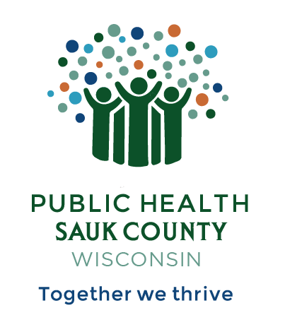
Public Health Sauk County
505 Broadway Street, Suite 372
Baraboo, WI 53913
Telephone: (608) 355-3290 Fax: (608) 355-4329

For immediate release July 23, 2025
Contact: Hannah Erdman, Health Educator
Public Health Sauk County
(608)-355-4319
Hannah.erdman@saukcountywi.gov

Sauk County Groups Host Free Community Event at Devil’s Lake on July 29th
Sauk County, Wis -- On Tuesday, July 29, 2025, from 10 AM - 4 PM, Sauk County will host a free community event at Devil’s Lake State Park. The event is family-friendly, alcohol and drug-free, and is open to all Sauk County residents. The event will be held on the South Shore of Devil’s Lake State Park in the White Oak shelter.
“We are working to bring more family and recovery-friendly community events to Sauk County,” explains co-organizer Hannah Erdman, Health Educator with Public Health Sauk County and facilitator of the Support People and Empower Recovery coalition. “This is a great opportunity for family, friends, and neighbors to enjoy a day of fun in the sun at one of our beautiful state parks and meet people in our community.”
Activities are planned throughout the day, starting at 10 AM with an optional free yoga class on the beach or a guided hike. People Helping People will provide brats for lunch with sides donated by local businesses and community members. Musicians Alexander Gabriel and Kasondra White will perform live from 11:30 AM - 12:30 PM. Two people in recovery from substance use will then speak, sharing their stories of hope.
Ben Miller, Case Manager for the Recovery Support Network program with Sauk County Justice, Diversion, and Support, provides details: “I’m excited for the 3rd annual Day at Devil’s Lake event, and the new morning yoga activity being offered this year. I am so grateful for all the donations and support from community volunteers, People Helping People, and other local businesses that have helped make the 3rd annual Day at Devil’s Lake a reality.”
Register for this free event at bit.ly/dayatdevilslake2025. Registration helps organizers plan for food and is required by July 27th to receive a free parking pass.
If you have any questions, please contact Hannah Erdman at hannah.erdman@saukcountywi.gov or call/text 608-963-8467.
This event is sponsored by Sauk County Justice, Diversion, and Support Programs, the Support People and Empower Recovery (SUPER) coalition, and Public Health Sauk County. Bill Harris from People Helping People in Baraboo and other local businesses are generously donating food and beverages.
###

