**Public Health** **Sauk County**

505 Broadway Street, Suite 372

Baraboo, WI 53913

Telephone: (608) 355-3290 Fax: (608)355-4329

**For immediate release May 29, 2025**

Contact: Rebecca Szydlowski, Public Health Nurse

Sauk County Health Department

(608) 355-4337 [Rebecca.Szydlowski@saukcountywi.gov](mailto:Rebecca.Szydlowski@saukcountywi.gov)

**Public Health Sauk County Holds Rural Safety Day Camp**

About 760 third-grade students learned important safety skills during this year's Rural Safety Day Camp, held May 6-8 at the Sauk County Fairgrounds. Public Health Sauk County organizes the three-day event each year, featuring learning stations and presentations on ten different safety topics.

Kids moved from station to station learning about chemical safety, fire safety, electrical safety, gun safety, farm equipment safety, how to be safe around small and large animals, water safety, bike safety, seat belt safety, and ATV/UTV safety.

This camp is one of the biggest programs that the Safe Kids Sauk County Coalition runs to help prevent kids from getting hurt. The coalition also offers car seat checks for free all year long and gives out safety items when they have them available.

“Our local businesses and organizations step up every year to help support this program,” says Public Health Nurse Rebecca Szydlowski, who serves as the Rural Safety Days Coordinator. “It’s amazing to see how our community comes together to keep kids safe.”

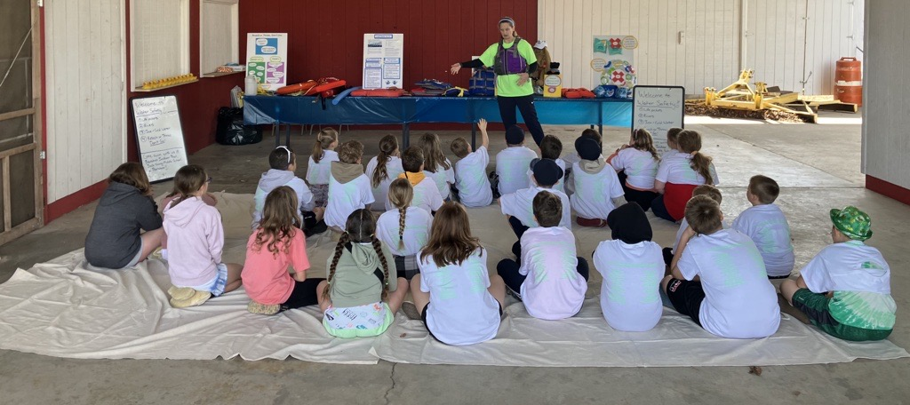Sponsors include: Allen Steele Company, Inc.; Alliant Energy; Baraboo Fire and EMS District; Baraboo FFA; Baraboo Police Department; Baraboo School District- Indoor Pool; Baxter Dental Center, Inc.; BP Viking Express Mart Reedsburg; Culvers; D. L. Gasser Construction; Farm & Fleet of Baraboo; Gerike Farms; Hartje Lumber, Inc.; Hill-Dale Veterinary Hospital; Jay’s Ag and Turf; Lake Delton Police Association; Lands’ End Reedsburg; Meyer Oil & LP; Mittelstaedt Sports and Marine; MW AgService- Mark Weihing; Morning Glory Veterinary Care; Public Health Sauk County; Redlin-Ertz Funeral Home; Reedsburg Area Medical Center; Reedsburg FFA; River Valley FFA; Sauk County Emergency Management; Sauk County Fairgrounds; Sauk County Association for Home and Community Education; Sauk County Humane Society; Sauk County Sheriff’s Department; Sauk County UW Extension; Sauk Prairie FFA; Sauk Prairie Healthcare; Sauk Prairie Healthcare Foundation; Slama Equipment; SSM Health; United Cooperative; WI Department of Natural Resources; WI Department of Transportation; Wisconsin Metals, Reedsburg; and Wisconsin Poison Center 1-800-222-1222.

Figure : Kara McCarty from the Baraboo School District- Indoor Pool teaching 3rd grade students about water safety.

For more information about Safe Kids Sauk County or resources specific to Sauk County, please visit <https://www.co.sauk.wi.us/publichealth/safe-kids> or contact Rebecca Szydlowski at [rebecca.szydlowski@saukcountywi.gov](mailto:rebecca.szydlowski@saukcountywi.gov) or 608-355-4337.

**About Public Health Sauk County**

Public Health Sauk County supports the well-being of all people in our community. Through wellness programs, environmental health initiatives, and a focus on creating systemic change, we cultivate healthier places and people so Sauk County can thrive. For more information on our programs and services, visit <https://www.co.sauk.wi.us/publichealth>.

###