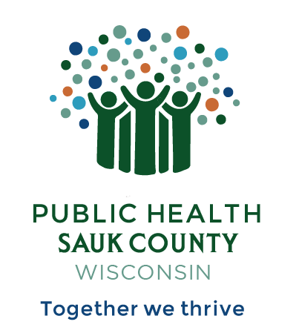
Public Health Sauk County
505 Broadway Street, Suite 372
Baraboo, WI 53913
Telephone: (608) 355-3290 Fax: (608) 355-4329

For immediate release March 26, 2024
Contact: Jennifer Weitzel
Deputy Director
Public Health Sauk County
608-355-3290 Jennifer.weitzel@saukcountywi.gov

Sauk City Waterworks Receives a Water Fluoridation Quality Award from the U.S. Centers for Disease Control and Prevention (CDC)

Sauk County, Wis – The Wisconsin Department of Health Services announced that Sauk City Waterworks has been awarded a Water Fluoridation Quality Award from the U.S. Centers for Disease Control and Prevention (CDC). Fluoridation is the adjustment of fluoride in drinking water to a level that is effective for preventing tooth decay. The award recognizes those communities that achieved excellence in community water fluoridation by maintaining a consistent level of fluoride in drinking water throughout 2022.
For 2022, a total of 1,209 public water systems in 27 states received these awards, including 30 in Wisconsin.
“Water fluoridation is one of the best investments that a community can make in maintaining the oral health of its citizens. It is equally as effective in preventing cavities in children and adults,” states Casey Hannan, MPH, Director, CDC Division of Oral Health. “Fluoridation is also highly cost effective. Studies continue to show that for every $1 a community invests in water fluoridation, $20 are saved in dental treatment costs.”
Community water fluoridation has been recognized by CDC as one of 10 great public health achievements of the 20th Century. CDC recommends water fluoridation as one of the most practical, cost-effective, equitable, and safe measures a community can take to prevent tooth decay and improve oral health.
“Public Health is about finding ways to protect and prevent against illness, disease, and other conditions that decrease quality of life,” shares Treemanisha Stewart, Director/Health Officer for Public Health Sauk County. “Fluoride in drinking water is one of those ways that we can protect our families from tooth decay.”

About Public Health Sauk County
Public Health Sauk County supports the well-being of all people in our community. Through wellness programs, environmental health initiatives, and a focus on creating systemic change, we cultivate healthier places and people so that Sauk County can thrive. For more information on our programs and services, visit https://www.co.sauk.wi.us/publichealth.

###

