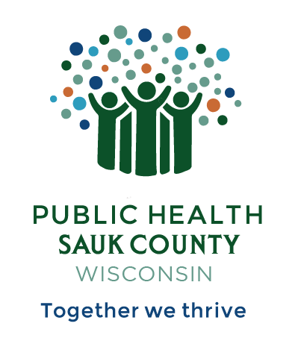
Public Health Sauk County
505 Broadway Street, Suite 372
Baraboo, WI 53913
Telephone: (608) 355-3290 Fax: (608) 355-4329

For immediate release February 13, 2024
Contact: Hannah Erdman, Health Educator
Public Health Sauk County
(608)-355-4319
Hannah.erdman@saukcountywi.gov

New Free Public Health Vending Machine at SSM Health St. Clare Hospital Emergency Room
Sauk County, Wis -- Public Health Sauk County and SSM Health are excited to announce a potentially life-saving tool in the Baraboo community: a free public health vending machine. The machine has Narcan Nasal Spray, Deterra medication disposal kits, and listings of local mental health and substance use resources. It is in the front entrance of the SSM Health St. Clare Hospital – Baraboo Emergency Room. The free supplies are available to all community members and visitors 24/7/365.
“The public health vending machine works just like any other vending machine, except all of the items are free for everyone,” says Hannah Erdman, a Health Educator at Public Health Sauk County, the agency that installed the vending machine. “The purpose is to provide free and easy access to life-saving supplies and resources.”
One of the free items in the vending machine is Narcan Nasal Spray. This over-the-counter medication can reverse an opioid overdose and save a life. “Even people who take their medication as prescribed may overdose,” says Erdman. “Narcan is important to carry with you or have in your home in case of an emergency, especially if opioids are in your home,” she states.
Bethany Basler is a person in recovery and a local peer recovery coach who works with the organization WisHope. She agrees on the importance of increasing access to supplies like Narcan. “Overdose can happen to anyone, any class, any race. It’s important to educate yourself on Narcan and how to use it. You never know when you may need to save someone’s life.”
Dr. Cheryl Goeckermann, Addiction Medicine provider at SSM Health Dean Medical Group in Baraboo, also supports easy access to these supplies that help keep people alive and connected to resources. “The opioid overdose epidemic continues to harm our community,” she states. “Narcan is an important tool in our toolbox for one simple reason: dead people don’t have a chance at recovery. If we can keep them alive, they have a chance for treatment. I am proud of St. Clare Hospital for being a leader in Sauk County by partnering with Public Health to provide this vending machine.”

Deterra medication disposal kits are also available in the vending machine. A person can use these pouches to get rid of unwanted or leftover medication at home. According to Erdman, properly disposing of medication makes our communities safer and our water supply cleaner.
The third item in the vending machine is a resource bag. This bag has a list of mental health care, substance use treatment, and recovery resources in Sauk County.
Public Health Sauk County purchased the vending machine and supplies with funding from a Wisconsin Department of Health Services grant. Erdman shares that she hopes to secure more grant funds to install these vending machines in other locations in our area. “We are so grateful to SSM Health St. Clare Hospital – Baraboo for being the first location to have a Public Health Vending Machine in Sauk County,” she adds.
###

