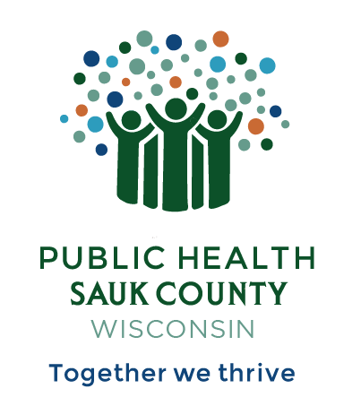
Public Health Sauk County
505 Broadway Street, Suite 372
Baraboo, WI 53913
Telephone: (608) 355-3290 Fax: (608)355-4329

For immediate release November 29, 2023

Contact: Hannah Erdman, Health Educator
Public Health Sauk County
(608) 355-4319
hannah.erdman@saukcountywi.gov

New E-Learning Narcan® Training Available for Community Members

Sauk County, Wis -- Public Health Sauk County has a new free e-learning Narcan® training available. This online training is self-paced and available anytime. It is for all community members, businesses, and organizations in our area. In this training, you will learn the signs of overdose and how to use Narcan® Nasal Spray. Narcan® is a harmless, life-saving medication that can reverse an opioid overdose and save a life.

An opioid overdose can happen when someone takes too much of an opioid or a mix of opioids, alcohol, or other drugs. During an opioid overdose, a person’s breathing can slow to a dangerous level or even stop. Narcan® Nasal Spray can stop these effects and return breathing to normal.

Opioids can include prescription painkillers like Hydrocodone, OxyContin, Vicodin, Percocet, fentanyl, and many others. Opioids also include illegal drugs like heroin, fentanyl, and counterfeit pills. Fentanyl, a very powerful opioid, sometimes laces other drugs like cocaine, methamphetamine, and fake pills. In Sauk County, over 70% of fatal and nonfatal overdoses involve an opioid.

“Even those who take their pain medication as prescribed can accidentally overdose, especially if taking painkillers with other medications or alcohol. If a painkiller is in your home, Narcan® Nasal Spray should be as well,” states Hannah Erdman, a Health Educator with Public Health Sauk County. “With this training you’ll learn about trends in drug use in our community and gain the skills to respond in an opioid emergency.”

Public Health Sauk County continues to offer free live Narcan® trainings online and in person with an instructor. Sign up for a live training or take the e-learning class today at UCanSaveALife.org. For questions, please contact Public Health Sauk County at 608-355-3290.

###

