**ISSUE STATEMENT / OUTCOME**

A plan for the re-use of a real property asset, that addresses short term issues and long term capacity needs.

**HISTORICAL ANALYSIS**

Zoned as general agriculture, the former Sauk County Health Care Center is located south of Reedsburg along State Road 23. It remains in Sauk County ownership. After moving into the new Health Care Facility the old facility along with several of the outbuildings were scheduled for removal. The removal/recycling of certain buildings is slated for completion by October of 2010. Two homes on the property (aka, Farm House & Administrators House) were sectioned off with approximately one (1) acre each and sold. The waste water treatment facility has been drained and cleaned.

The parcel consists of 565 acres. This is divided between 264 acres of cropland, 54 acres of pasture, 60 acres of woodlands, 26 acres of bottom land stream bank corridor, 16 acres that was previously used as a clay borrow site, an 82 acre restored wetland and prairie area, and approximately 55 acres that contains the facilities that were used for the Health Care functions consisting of buildings, parking lots, and the sewage treatment facility. The farmed lands are located on good productive soils and farmed under a conservation plan, and are currently being rented along with the farm buildings. Woodland is managed under a forest management plan. The restored wetland and prairie habitats are managed for wildlife production. All lands are open to public access for hunting, fishing hiking, wildlife observation, and other uses. The restored wetland and prairie habitats were established with the long- range goal of use as an educational site, and a fishery easement was purchased by the DNR to provide public access*.*

The property also contains a number of unique features that should be carefully considered in the future plans for the reuse of the property. These include: Cemetery, underground storage wells, utility access, on-site buildings with historical significance and additional structures for storage and rental. The Sauk County Health Care Center property and farm (Farm) is a significant county asset that includes farmland, wetland and prairie habitats which have significant value that exceeds valuation by monetary measures alone.

**COMPREHENSIVE PLAN ANALYSIS**

The County Comprehensive Plan makes various recommendations regarding the importance of agriculture and preservation of the resources that contribute to the viability of the agricultural base of the county. Fifty-four percent of the land in Sauk County is agricultural. The following excerpts from the comprehensive plan articulate the importance of the retention of the land for agricultural purposes.

Farmland Preservation

Sauk County will be a leader in agriculture. The County’s dedication to the family farm and early recognition of alternative farming practices will create a wide variety of alternative practices. The county will seek to balance the economic needs of landowners with the continuation of family farms and promote successful resource conservation and land use practices, maintain large contiguous blocks of farmland, and develop strong farm educational networks.

The plan highlights the importance of managed growth so that cultural, natural and agricultural resources are preserved. The comprehensive plan underscores the importance of the maintenance of contiguous agricultural and forest land as vital to retaining the rural beauty and natural systems that are dependent upon large tracts of undeveloped forested areas.

The majority of land in Sauk County is used for agriculture; an industry that accounts for $587.4 million in total economic activity and provides about 5,600 jobs. Sauk County residents value many aspects of the agricultural industry. Clearly, agriculture is an important socio-economic activity in Sauk County.

The table below offers detailed objectives that could influence the re-use of this large tract of land.

|  |
| --- |
| **Comprehensive Plan Detail**  **Relevant Agriculture Resources Objectives**  ***Objective 1*** – Develop programs to maintain agriculture as a key component of the local economy.  ***Objective 3*** – Protect the viability of farm operations by minimizing the fragmentation and parcelization of agricultural land to maintain the operational efficiency of the land.  ***Objective 4*** – Develop programs and policies within County departments that create proactive, supportive partnerships with agricultural producers as a means of protecting the natural environment while promoting economic vitality.  ***Objective 7*** – Develop a multi-county agricultural tourism program that enhances direct farmer to consumer marketing.  ***Objective 8*** – Support programs for new farmers.  ***Objective 9*** – Establish a local food system that emphasizes the production of food that is sold within the southern Wisconsin region.  ***Objective 10***– Enhance producer profitability by providing access to science-based information and programs that aid producers in improving efficiencies through improved methods, management, and technology.  ***Objective 11*** – Provide educational opportunities to non-farm rural homeowners to help them gain a better understanding of Wisconsin’s right-to-farm law, fence law, and other regulations that are in place to assure that farmers are able to maintain their production systems.  **Relevant Natural Resources Objectives**  ***Objective 1* -**Create regional green space programs that preserve permanent regional connections of open space, historic landscapes, environmentally sensitive areas, waterways and low-impact recreational lands.  ***Objective 2* -** Expand the community’s understanding of the economic, ecologic and social impacts of forests.  ***Objective 3* -** Develop and apply development standards that protect the environment and promote the sustainable use of natural resources.  ***Objective 4* -** Establish programs to minimize forest fragmentation, reestablish forested areas and explore techniques that would allow fragmented forests to retain a larger portion of their original ecological, economic, and social values.  ***Objective 5* -** Develop initiatives to maintain and protect threatened natural areas with cultural, ecological and economic significance. |

**STAKEHOLDER ANALYSIS**

The committee utilized input from officials of the Town of Reedsburg. The committee also solicited input from County oversight committees and departments as it pertained to potential future use. The following stakeholders have been identified as having a compelling interest in the future use of the existing Health Care Center property.

*County Board of Supervisors*. Responsible for policy design and programmatic oversight. The Board of Supervisors’ perspective is one that focuses on providing optimal service within the confines of limited resources and being accountable to taxpayers. Exploration of best use of this real property asset is paramount.

*Town of Reedsburg.* Consideration should be given to the preferences of the Town when investigating options for re-use. The town expressed the desire to maintain the integrity of the site as an agricultural venture.

*County taxpayers*. Consideration should be given to the county taxpayer as the funding source of many county initiatives.

*County agencies.*

Land Conservation Department has had a vested interest in developing appropriate conservation practices with the property as it exists:

* Demonstrations of conservation practices include: Wetland and prairie restoration; stream restoration/management.
* Rental of farm land.
* Maintenance of the farm land for potential rental to a cooperative interested in developing innovative agri-business related industries.

Parks: Integration of future recreational use planning with comprehensive reuse plan for the facility.

* Snowmobile trails
* Develop public fishing access, camping, paved and unpaved hiking & biking trails, to address those needs prominently identified by responses to the CORP public opinion survey.
  + Maintain scenic vistas.
  + Develop site plan for integrating recreational/conservation/research uses.
  + Maintain as a large parcel of public land.
  + Develop a recreational trail connection with other public lands and “400” trail.
  + Potential dog park.
  + Develop interpretative trails, bird watching

Highway:Would need to be assessed as an appropriate location for a use as a part of the Highway operation.

*Special Interest Groups*

Historic Preservation: There has been some interest in preserving buildings perceived to be of historic value, specifically the firehouse.

**POTENTIAL FUTURE USES**

**Ag Forest / Agricultural / Undeveloped and Forest**

The unique features of the property, and the location of the property offer potential for a variety of short term and long term uses. Plans which currently exist that can be utilized for informing the process are the Comprehensive Outdoor Recreation Plan and the County Comprehensive Plan (both of which are detailed above ).

Ultimately, the county’s future perspective is focused on appropriate stewardship. In discussing the agricultural / forest lands a few themes emerge:

* Continued agricultural use of the land is ultimately the highest and best use of the ag land.
* Large contiguous blocks of farmland and forests are preferred. This is consistent with best use practices regardless of ownership (public vs. private).
* There is an emphasis at both the Town level and County level to maintain the agricultural focus of the property.
  + This focus can be maintained in retaining the property and identifying potential programmatic development around ag based industries. It is likely that this would require partnership and development of cooperative ventures. Vision, identification of needed resources and time to develop opportunities would be requisite.

|  |  |  |  |  |  |
| --- | --- | --- | --- | --- | --- |
|  | Site # | Description | Year | Floors | Sq. Ft. |
| B | 003-002 | Well House # 2 | 1946 | 1 | 135 |
| G |  | Tan Storage Shed | 1930 | 1 | 1480 |
| L | 003-013 | Fire Department Building | 1910 | 1 | 450 |
| O | 003-017 | 3 Stall Garage | 1988 | 1 | 864 |
| P | 003-018 | Bus Garage | 1987 | 1 | 1200 |
| Q | 003-022 | Barn | 1930 | 1 | 4200 |
| AA | 038-003 | Tin Storage Shed | 1969 | 1 | 4800 |

* + This focus can also be achieved through the sale of large contiguous parcels of farm and forest land. Existing zoning requires 40 acres to build, and conservation easements would not devalue the property and would be appropriate for specific portions. If a sale was to be undertaken, one recommended format would be for an auction. Partial sales do not devalue the property. Divisions would need to be carefully designed to avoid potential land use conflicts.
  + Typically the cost of providing service for rural development is not equal to the tax base generated. The Center for Land Use Education conducted an analysis of the Cost of Community Services. Based on data collected from 1993 to 2004, in the State of Wisconsin it shows that residential has the largest ratio. For every dollar of tax generated it costs $1.19 to provide service. Conversely, agricultural land only costs $0.23 to provide service for every dollar of property tax. (*It should be noted that variances depending upon local conditions significantly impact the actual costs for a specific area*. Downloaded from [http://www.uwsp.edu/cnr/landcenter/COCS/COCSpresentationweb.pdf, on September 14](http://www.uwsp.edu/cnr/landcenter/COCS/COCSpresentationweb.pdf,%20%20on%20September%2014), 2010.)

**Remaining Building Inventory**

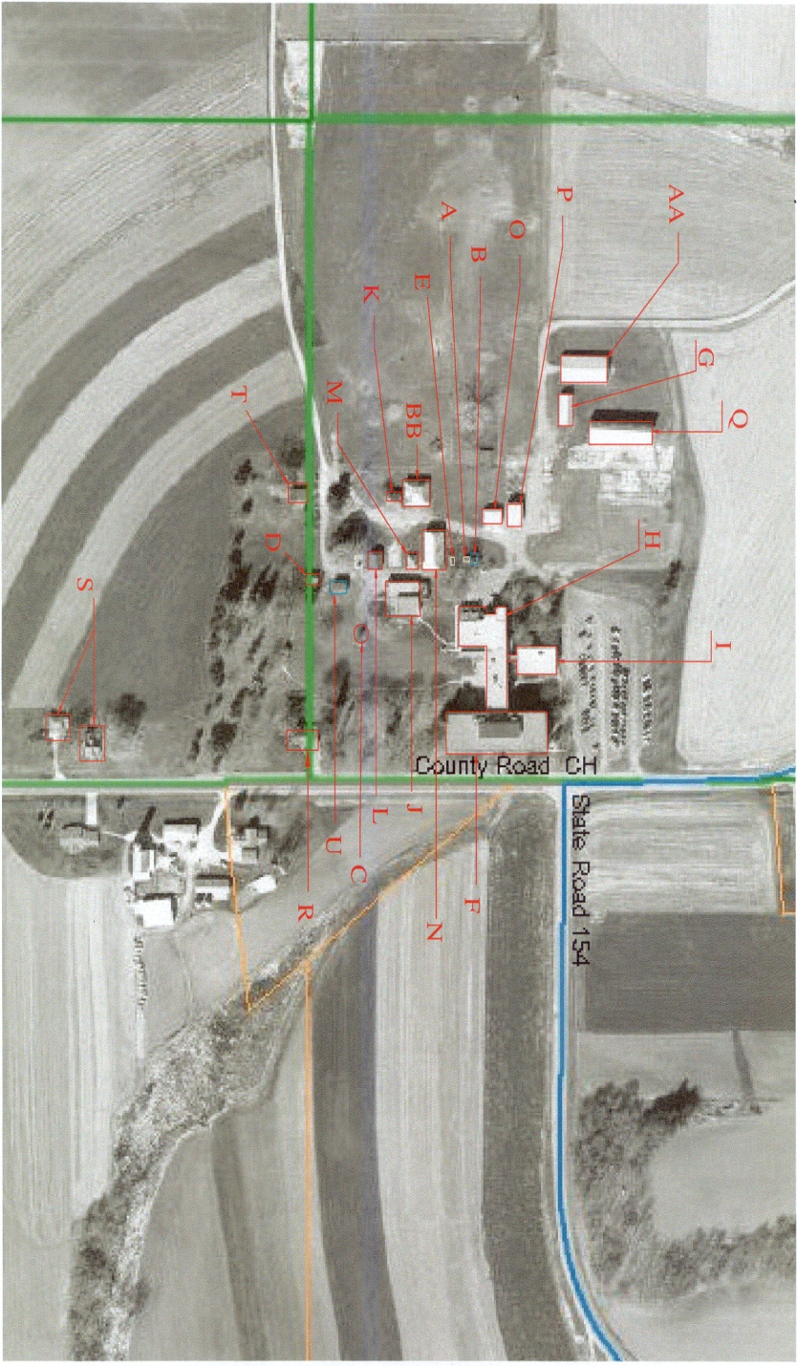

Seven buildings will remain on the property.

Descriptions are in the chart above and can be located by alpha character on the aerial view to the right. All other numbered buildings will be removed. The following page contains pictures of each of the remaining buildings. The approximately 28 acres that comprised the properties building site could be utilized as park and recreation space, with interpretive centers and publicly accessible park features.

Aerial view: Building locations

|  |  |
| --- | --- |
| P%20-%20Bus%20Garage%2010-21-2008%203-06-46%20PM%20640x480  BUS GARAGE | O%20-%20Three%20Stall%20Garage%2010-21-2008%203-06-41%20PM%20640x480  **THREE STALL GARAGE** |
| **AA - Tin Storage Shed 10-21-2008 3-21-40 PM 640x480**  TIN STORAGE SHED | **G%20-%20Tan%20Storage%20Shed%2010-21-2008%202-58-41%20PM%20640x480**  TAN STORAGE SHED |
| Q%20-%20Barn%2010-21-2008%203-07-01%20PM%20640x480BARN | **L%20-%20Fire%20Dept%20Building%2010-21-2008%203-03-56%20PM%20640x480**  FIREHOUSE |
| B%20-%20Well%20%232%2010-21-2008%202-49-07%20PM%20640x480%2010-21-2008%202-49-07%20PM%20640x480 WELLHOUSE |  |

**Special Features**

**Cemetery and Wetlands**

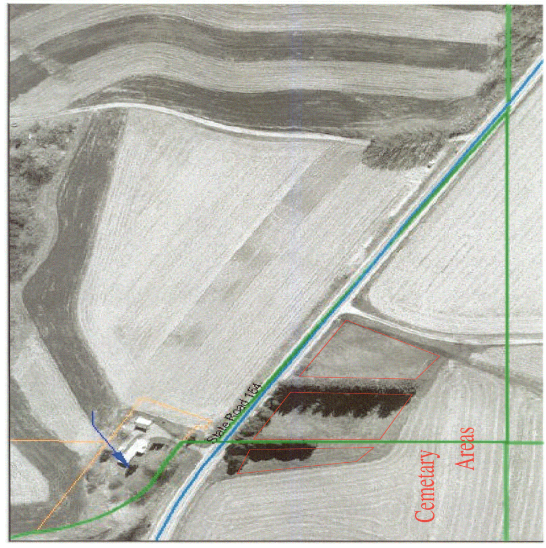The property has a number of special features. Two of the features pictured here are the cemetery on the right (red outline), and the restored wetlands and creek area (below).

Cemetery

The County is obligated to retain and maintain the cemetery. The wetland, which is not contiguous with the farm property, is located in totality within the Town of Westfield. It has a conservation easement and is publicly accessible. This property could potentially be sold. Both conservation easement area and cemetery provide space for development of publicly accessible parkland. Each could accommodate locations for an interpretive center and publicly accessible recreational facilities.

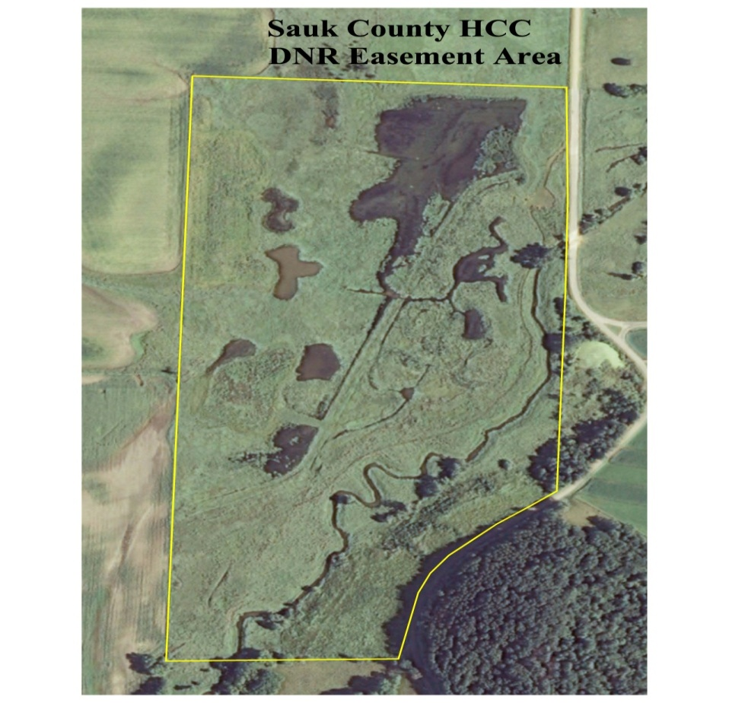Ongoing maintenance costs for these facilities would be minimal.

Wetlands

**Existing Trails**

Currently a snowmobile trail runs through the property. Maintenance of this route is attainable under private or public ownership.

**POLICY ALTERNATIVES**

The table below summarizes the committee discussion on sale versus retained County ownership. It incorporates discussion over the reality of long term development options and short term needs of the county.

|  | **Sale of Property** | **County ownership (status quo)** |
| --- | --- | --- |
| **Cost** | Results in proceeds from the one time only sale of the property. Property goes back on the tax roll.  What is the cost of selling parcels?  Ultimately the choice to retain or sell the property is not based on “cost” or “savings” but on a public policy platform. | What is the cost of selling parcels?  Long term investment in “speculative” ventures - availability of funds and resources to invest in emerging technologies. Potential for development of agri-related industries, experimental farms, etc. that are not core to the Sauk County mission. |
| **Future Consequences** | Potential for issues developing with rural development. | Potential need of the property for County operations. Identifying potential relationships and uses of properties based on long term needs minimizes consequences and risk for the future. Lost opportunity – once the property is sold acquiring the same type of property for the same price is not feasible. |
| **Constraints / Political Feasibility** | Loss of rental income. Should the county own assets that it does not absolutely need (mission centric). Return back to private ownership because it is no longer to be utilized for the purpose for which it was acquired. | What is the public purpose of maintaining ownership? Is an investment in infrastructure or development reasonable within the current and future fiscal climate? |
| **Flexibility-**Can the alternative serve more than one purpose? | Yes – if conservation easements are utilized to retain the agricultural focus desired by both the County and the Town. | Yes – options for public private partnership and development of new programmatic directions. |
| **Risk-**Does the alternative have a high chance for failure? | No | Risk is incurred with development of new programmatic directions that would be tied to the reuse of the property. |
| **Merit-**Is the issue addressed? | Yes – it allows for the reuse by outside parties of a underutilized county asset. | Decision is forestalled to a future date as new information becomes available. |
| **Compatibility-**Does the option comport with comprehensive plans? | Sale would be consistent with comprehensive plans as lots are composed to address an ongoing agricultural focus. | Potentially – if continued ownership equated to the continued rental of the farm lands and preservation of natural areas. |
| **Reversibility-**How difficult will it be to return to the prior conditions if the option fails? | Once the property is sold, reversion to County ownership is highly unlikely. | Potential “sales” of the property as a whole or portions of the property remain viable at any time and are dependent upon market conditions and lease terms. |

**Cost comparison:**

**Sale of property**

The property has an estimated sale price of **$2 million**. Five area realtors viewed the property and presented information on the potential sale of this property including potential sale price, and the marketability of the property. It was noted that the property is marketable and there is a perceived desire for the acquisition of agricultural land. The table below is a summary ofsales of similar properties within the vicinity of the Health Care Center. They show a great deal of variability in actual dollars per acre. Actual sale price may vary from the estimate provided based on market conditions and property valuations at the time of sale.

|  |  |  |  |  |
| --- | --- | --- | --- | --- |
| **Acreage** | 30.38 | 162.25 | 91.8 | 76 |
| **Sale Price** | $117,000. 2009 estimated fair market value of just the improvements was $28,100.  So if that value is subtracted from the $117,000, the difference is $88,900. That amount divided by 30.38 acres comes to **$2,926/acre for the land**. | Sold for $567,900, and the 2010 assessed value shows only $17,100 worth of improvement value. Using the 2009 assessment ratio (2010 not yet available) those improvements would have an estimated fair market value of $20,500, so subtracting that leaves a value of $547,400. Divided by 162.25 acres: **$3,374/acre for the land**. | The sale was for $390,200, so that comes out to **$4,250/acre**. | Sold in parcels of approximately 17, 17, 25.5, and 16.5 acres. Average price per acre was $3,713; with a range from **$3,030 to $4,390 per acre.** |
| **Location** | Section 28 of the Town of Reedsburg Contiguous to the HCC parcel that is west of STH 23 at a corner. | Section 3 of the Town of Westfield. This is farmland just east of the part of the HCC/Farm in the Town of Westfield. | Section 4 of the Town of Westfield. It is about a mile west of the HCC/Farm parcels in the Town of Westfield. | Sections 27 & 34 of the Town of Winfield, approximately 1 mile north of City of Reedsburg. Six miles north of HCC. |
| **Sale Date** | July, 2009 | December, 2009 | April, 2010 | October, 2010 |
| **Description / notes** | There are a few sheds and a barn on the parcel. |  | Vacant land. It is basically all farmland except the road rights of way and 3 acres of woods. | Vacant land, primarily farmland, with some wooded acreage. |
| *Figures are rough calculations based on the recorded documentation. There may be other factors involved that are not noted. The Town of Reedsburg is having a revaluation this year, but we have not yet received new values from the assessor.* | | | |  |

**Tax revenues** (4)

|  |  |  |  |  |
| --- | --- | --- | --- | --- |
| Assessment categories | Value per acre (1) | Acreage | Assessed value | Annual Tax revenue (County portion only) (3) |
| Town of Reedsburg | | | | |
| Ag Forest | 1,050 | 84 | $88,200 | $410.95 |
| Agricultural (2) | 200 | 291 | $58,200 | $271.14 |
| Building sites | 5,000 | 28 | $140,000 | $652.23 |
| Undeveloped | 250 | 80.31 | $20,100 | $93.64 |
| Town of Westfield | | | | |
| Forest | 2100 | 5 | $10,500 | $50.75 |
| Undeveloped | 250 | 77.04 | $19,260 | $93.66 |
| Total |  | 565.35 |  | $1,572.37 |

Notes:

1. All acreage is approximate based on USDA maps and rental contracts. Value per acre is reduced based on the following: Ag forest assessment reduction of 50%; Undeveloped reduction of 50%; and Ag Use value has an average value of $200 per acre. Values provided by Town Assessors.
2. Includes cropland and pasture
3. Calculated based on 2007 mil rate
4. When spread out over the entire county the potential for “tax relief” is minimal

**Bond refunding**: Potential for a principle payment of $1,140,000 for the Law Enforcement Center and the Communications network (fiber) on. Total interest savings in payoff of callable debt (10/01/11): $57,343. There would be corresponding reductions in tax levy in 2012 and 2013 respectively of $741,503 and $455,840.

**Investment**: If the entire $1,850,000 ($2,000,000 – sale costs of $150,000) were invested, and had a rate of return of 1.3% (current CDARS rate), it would earn $123,417 in interest by 2015. If the bond refunding was undertaken and the balance of $710,000 utilized for investment it would earn $47,366 in interest income by 2015.

**Other**: Use of proceeds from the sale could also be utilized to fund one time only capital expenditures or be added to fund balance and retained for future uses.

**Retention of Property**

Rental income from County Farm per year: $40,800 per year. Existing lease expires March 01, 2012.

* + Crop land for three year agreement $114,000 total ($38,000 per year).
  + Pasture land for a three year agreement $6,000 total ($2,000 per year).
  + Barn rental is $2,400 for a three year agreement ($800 per year).

Annual County management/maintenance cost for property: $25,500.

* + Estimated general maintenance - $10,000.
  + Estimated staff time for farm management - $7,000.
  + Ongoing yearly costs with farm maintenance - $8,500.
  + Costs for creation of and maintenance of any park or recreational land will be determined based on usage plans.

**Analysis of sale versus retention**

|  |  |  |  |  |
| --- | --- | --- | --- | --- |
|  | **Sale** |  | **Retention** |  |
| Analysis projects potential levy savings over a 5 year time frame. | | | | |
| Expenses | 150,000 | Estimated costs for survey work, rezoning, and auction services. | 127,500 | Ongoing maintenance costs associated with farm and general upkeep of property. |
| Revenues | (2,000,000) | Assumes 1.14 million for debt; balance invested for 5 years at 1.3%. | (204,000) | Farm rental |
| Levy impact (favorable) | (1,197,343) | Debt service and interest averted | (76,500) |  |
| Asset remaining at 5 years | 772,971 | Cash + interest earnings | 2,000,000 | Real property asset |
| Table is based on known expenses. Further development would change analysis. | | | | |

**Investment and payoff detail**



|  |  |  |  |  |  |  |  |  |  |  |  |  |  |  |  |  |  |  |  |  |  |  |  |  |  |  |  |  |  |  |  |  |  |  |  |  |  |  |  |  |  |  |  |  |  |  |  |  |  |  |  |  |  |  |  |  |  |  |  |  |  |  |  |  |  |  |  |  |  |  |  |  |  |  |  |  |  |  |  |  |  |  |  |  |  |  |  |  |  |  |  |  |  |  |  |  |  |  |  |  |  |  |  |  |  |  |  |  |  |  |  |  |  |  |  |  |  |  |  |  |  |  |  |  |  |  |  |  |  |  |  |  |
| --- | --- | --- | --- | --- | --- | --- | --- | --- | --- | --- | --- | --- | --- | --- | --- | --- | --- | --- | --- | --- | --- | --- | --- | --- | --- | --- | --- | --- | --- | --- | --- | --- | --- | --- | --- | --- | --- | --- | --- | --- | --- | --- | --- | --- | --- | --- | --- | --- | --- | --- | --- | --- | --- | --- | --- | --- | --- | --- | --- | --- | --- | --- | --- | --- | --- | --- | --- | --- | --- | --- | --- | --- | --- | --- | --- | --- | --- | --- | --- | --- | --- | --- | --- | --- | --- | --- | --- | --- | --- | --- | --- | --- | --- | --- | --- | --- | --- | --- | --- | --- | --- | --- | --- | --- | --- | --- | --- | --- | --- | --- | --- | --- | --- | --- | --- | --- | --- | --- | --- | --- | --- | --- | --- | --- | --- | --- | --- | --- | --- | --- | --- | --- |
| |  |  |  |  |  |  |  |  |  |  |  |  | | --- | --- | --- | --- | --- | --- | --- | --- | --- | --- | --- | --- | | **Option 2 - Payoff Debt Service** | | | | |  |  |  |  |  |  |  | | Principal of $1,140,000 is callable (can be paid off) in October 2011. In 2014 there is $7,050,000 in callable debt. | | | | | | | | | | |  | | Principal Repayment | Interest Expense Averted | Total | |  | |  |  |  |  |  |  | | 275,000 | 11,000 | 286,000 | | From $24.5 million LEC bonds issued 12-1-01 | | | | | |  |  | | 425,000 | 30,503 | 455,503 | | From $3.45 million Communications infrastructure notes issued 5-1-04 | | | | | | | | | **700,000** | **41,503** | **741,503** | | **Total** **2012 Levy Reduction** | | |  |  |  |  |  | |  |  |  | |  | |  |  |  |  |  |  | | 440,000 | 15,840 | 455,840 | | From $3.45 million Communications infrastructure notes issued 5-1-04 | | | | | | | | | **440,000** | **15,840** | **455,840** | | **Total** **2013 Levy Reduction** | | |  |  |  |  |  | | 1,140,000 | 57,343 | 1,197,343 | | **Total Levy Reduction for 2012 and 2013** | | | | | | | | | *Issue: Prepayment of debt service with other sources creates the potential for a spike in debt service levy in 2014.* | | | | | | | | | | | | |

**ALTERNATIVES CONSIDERED**

**Alternative 1 – Sale of the property.** This would include selling all of the property except the cemetery with conservation easements. This alternative is one that pertains to the philosophical perspective that the county is better served by disposing of real property assets that: There is no immediate need for; those for which the original public policy purpose has changed; And, where private ownership is deemed a higher / better use of the property.

* Allows for utilization of the area surrounding the cemetery to develop public access park facilities.
* Allows for development of large sized agricultural properties, preserving the agricultural use of the land, and maintaining habitat.

**Alternative 2 – Retain land for potential future use.** This would entail retaining the farm and surrounding properties to allow for the development of a plan for future use.

* Maintain ownership of the property and continue rental of the farm.
* Utilize the site to develop public access park facilities.
* Explore public – private partnerships, and partnerships with other institutions (Madison College).
* Utilizing the land asset and farm asset to design programming that enhances conservation and farming practices.

**Alternative 3 – A combination of alternatives 1 and 2.** Retain portions of the property that have significance to county government operations (cemetery, wetlands, and historic firehouse with conservation easements in place). Portions that are not core to county government operations (farm land) may either be retained as rental property or sold in large tracts with conservation easements in order to retain the agricultural purpose of the property. There was stakeholder input in favor of selling the property for private farm use.

* The key recommendation was that the parcels be maintained as agricultural lands, therefore if sold in large enough parcels with conservation easements the integrity of the land for agricultural uses is preserved.
* The cemetery, wetlands and the fire house have restrictions and are required to be retained and maintained by the County.
* Allows for utilization of the remaining area surrounding cemetery and historic fire house to develop public access park facilities, or use by other county departments. (ie: Highway–water, Parks –storage).

**RECOMMENDATION**

In developing re-use recommendations the committee considered the overall mission and vision of the county as well as the best return for the county taxpayer. Predominant goals: The Sauk County Health Care Center property and farm is a significant county asset. It is a large contiguous plot that encompasses farmland, wetland and prairie habitats. It has significant value that exceeds valuation by monetary measures alone. The re-use recommendation focuses on maintenance of the unique components that define the property by recommending **Alternative Number 3.** The recommendation is for the restored wetlands; and the land surrounding the historic fire house and cemetery to remain in County ownership and be operated as public access parks. The second part of the recommendation is that the argricultural land under production remain in production whether owned privately or through continued County ownership.

This alternative allows for:

* The maintenance and development of the site in a manner consistent with the Town of Reedsburg Comprehensive Plan, County Comprehensive Plan, and the Comprehensive Outdoor Recreational Plan, which focuses on continued agricultural use (refer to detail on page 2).
* Considers that objectives for sale and / or re-use fall within the context of core county mission.
* Retains key elements of the property within public ownership, namely, the cemetery, the restored wetlands, and the historic firehouse.
* Considers the continued use of the farm for agricultural purposes.
* Development of a County Park presence with appropriate designations of the historic operation of the poor farm and skilled nursing facility for over 150 years at that site.