**LGC Program Agreement**

The LGC Program Agreement(this “***Agreement***”), dated and effective as of the date of last signature below (*“****Agreement Effective Date****”*), is by and between _________________ (“***Customer***”) and National Coalition of STD Directors (NCSD) (***“Service Provider***”). Capitalized terms used in this Agreement and not otherwise defined herein shall have the meanings ascribed to such terms in the Agreement.

# **DEFINED TERMS**: The following terms will have the meanings as set forth below.

## “Client Portal” means the portal operated by Laboratory for Customer’s ordering and surveillance of laboratory services furnished by Laboratory.

## “Clinician Order” means an order from a Service Provider’s contracted clinician, which authorizes lab test processing.

## “Custodial Account” means the deposit account maintained by Service Provider on behalf of Customer and its other clients, for the deposit and administration of funds to Laboratory for kits ordered through the Client Portal.

## “EULA” means the End User Agreement between Laboratory and Customer governing the services to be provided by Laboratory through the Client Portal.

## “Laboratory” means LetsGetChecked, Inc., the laboratory utilized by Service Provider to process the Participants’ Test Kits and return the Results.

## “Participant Portal” means the Service Provider’s branded web portal, “Check Yourself”, whereby Participants may track the status of the Test Kit and the Results. The “Check Yourself” portal is powered by LetsGetChecked, Inc. proprietary software.

## “Results” means the Test Kit screening result.

## “Standard Five Test” means the screening test for Chlamydia, Gonorrhea, HIV (I, II, P24 antigen), Syphilis, Trichomoniasis.

## “Test Kit” means a sample collection kit that allows Test Administrators to capture Participants’ biological samples outside a laboratory setting and mail them to Laboratory for processing.

# **EULA:** Pursuant to the EULA, Customer will be provided access to the Client Portal and have the opportunity to order Test Kits. This Section summarizes the services provided by Laboratory pursuant to the EULA. Customer acknowledges and agrees that Service Provider is not responsible for any of the following services.

## **Test ADMINISTRATION Services:** Laboratory offers different modules of Test Ordering and Administration as set forth in Exhibit 1. Each Test Kit will include the test components for as set forth in Exhibit 2.The fees for the Services are set forth in Exhibit 3. The fees are subject to change at the discretion of the Laboratory.

## **Testing Services:** The general workflow for services is shown in Exhibit 4. Upon activation of the Test Kit and return of the Samples, Laboratory will provide the testing services which shall include the following:

### Laboratory Clinician Authorization. As part of the Participant registration, Laboratory will engage an appropriately credentialed clinician to provide review and enter a Clinician Order as appropriate.

### Sample Processing: Upon receipt of the Test Kit, the sample will be processed by Laboratory and Results returned via secure connection. In the event that the Participant has not collected a sufficient sample for processing this information will be included on the Participant’s Portal and in the reporting to Customer. In the event of an inadequate Sample or other error, Laboratory will arrange for re-testing of the Participant at the standard rates.

### Laboratory Clinician Review: Laboratory’s appropriately credentialed clinician will review the Results, adding clinical notes if required prior to releasing the Results to the Participant.

### Participant Results: Upon completion of the clinician’s review, normal Results will be sent to the Participant’s online account. For abnormal Results, Laboratory’s nursing team will make up to three (3) calls to connect directly with the Participant.

* + - 1. Upon connecting directly with a Participant and delivering the Results, Laboratory’s nursing team will release the Results to the Participant’s account. If Laboratory has been provided with the Participant’s email, upon releasing Results, Laboratory will send an e-mail confirming availability of results in the Participant’s account.
      2. If the Laboratory nursing team is unable to connect with the Participant after two (2) call attempts, Laboratory will release the Results to the Participant’s account. If Laboratory has been provided with the Participant’s email, upon releasing results, Laboratory will send an e-mail confirming availability of Results in the Participant’s. A Participant may request a call from the Laboratory’s nursing team.

### Client Results: Laboratory will send the Participant Results to Customer via the Client Portal. Except as otherwise agreed by the Parties, Customer is responsible for follow up with the Participants to ensure any necessary follow-up care for positive and inconclusive Results.

# **Service Provider Role**: Service Provider shall establish a Custodial Account on behalf of Customer and its other customers. Service Provider shall assist Customer with account creation and administration on the Client Portal. Service Provider shall disburse funds to Laboratory for orders made using Customer’s account. Service Provider shall have no obligation to disburse any funds to Laboratory in the event Customer has exhausted its funds in the Custodial Account. For clarity, and without limitation of the foregoing, Service Provider shall not have any responsibility for the services identified as Laboratory’s responsibilities under this Agreement or the EULA.

# **TERM AND TERMINATION**

## Term. This Agreement is effective as of the Effective Date set forth above and shall remain in effect for one (1) year (the “Agreement Term”), unless earlier terminated as provided for in the Agreement and this Agreement. Upon the expiration of the Initial Term, this Agreement shall be automatically renewed for periods of one (1) year thereafter (each a “Renewal Term” and the Initial Term together with any Renewal Term are the “Term”) unless either Party provides written notice of termination to the other Party at least sixty (60) days prior to the expiration of the then-current term. Following termination of this Agreement, in the event Service Provider holds funds contributed by Customer in the Custodial Account, which funds are not needed to satisfy any of Customer’s liability to Laboratory pursuant to the EULA (the “Leftover Funds”), Service Provider shall promptly refund the Leftover Funds to Customer.

# **DISCLAIMER OF WARRANTIES:** Test Information, including lab reports do not constitute a definitive DIAGNOSIS. POSITIVE RESULTS ARE INDICATIVE OF AN ACTIVE INFECTION, BUT DO not constitute a definitive diagnoses and further testing will be required from PARTICIPANT’S physician or other licensed healthcare professional. NEGATIVE RESULTS DO NOT PRECLUDE INFECTION AND SHOULD NOT BE USED AS THE SOLE BASIS FOR PATIENT management DECISIONS. NEGATIVE RESULTS MUST BE COMBINED WITH CLINICAL OBSERVATIONS, PATIENT HISTORY, AND EPIDEMIOLOGICAL INFORMATION. AS WITH ALL SCREENING TESTS, IN A CERTAIN NUMBER OF CASES THERE CAN BE INCIDENCES OF FALSE-POSITIVE AND FALSE-NEGATIVE RESULTS. A NEGATIVE TEST MAY OCCUR IF THE SAMPLE HAS BEEN COLLECTED IMPROPERLY.

# **MISCELLANEOUS:**

## Counterparts. This Agreement may be signed in counterparts. An electronic submission of a signature page will be considered an original signature page.

## No Third Party Beneficiaries. There are no intended third party beneficiaries under this Agreement. In the event Customer wishes to bring a claim against Laboratory for any services provided by Laboratory, Customer shall have no right to do so under this Agreement. Customer acknowledges and agrees that any claim relating to Laboratory’s services must be brought under an agreement between Customer and Laboratory, such as the EULA.

## Entire Agreement. These terms and conditions contained in the Agreement and this Agreement constitute the Parties complete understanding and agreement relating to the subject matter hereof. In the event of a conflict between this Agreement and the Agreement, this Agreement will control. No other terms and conditions, beyond those contained herein, will be valid unless mutually agreed to by Customer and Service Provider in a writing signed by authorized representatives of each party.

## **ACCEPTED AND AGREED:**

|  |  |
| --- | --- |
| **(Customer)**  By:  Name: ______________________________  Title: _______________________________  Date: | **National Coalition of STD Directors**  By:  Name: ___________________________  Title: ____________________________  Date: |

**EXHIBIT 1**

**TEST ADMINISTRATION OPTIONS**

The following is a description of laboratory’s test administration options. it is subject to change and, in the event of a conflict between this exhibit and the service descriptions set forth in the EULA, the EULA shall govern.

**Module A Landing Page - Ship to Participant Home Services –** Laboratory will ship Test Kits to the Participants’ homes for self-collection of the sample as set forth below:

**1 Landing Page**

(a) Landing Page – Service Provider and Customer will have access to a landing page accessible via a link from the Customer website to permit Participants and/or Customer to order Test Kits.

(b) Account Creation. Through the landing page, Participants may create an account with Service Provider where they will provide the applicable demographic and medical information, complete the suitability questionnaire for the applicable Test Kit, and provide a shipping address.

**2 Written Material Approval**. The parties do not intend for written Participant communications to be provided under this Agreement. In the event the parties mutually agree to add such services (which may incur additional fees), Customer will review and approve in writing any mutually agreed upon additional written Participant communication materials,and assure compliance with all applicable laws and regulations. Customer changes will be requested and approved in writing. All content will be approved no less than one (1) week prior to commencement of the Implementation Plan. For purposes of this Agreement:

(a) Outreach Languages. Languages for Participant communications will be in English. Additional languages may result in additional fees.

(b) Written content revisions are limited to three (3) iterations per script or written document. Changes made after content has been approved will result in delays and additional fees.

**3 Order Confirmation and Shipment**. Upon order confirmation, Laboratory will utilize a trackable method to ship the Test Kit to the Participant. Neither Laboratory nor Service Provider is not responsible for confirming Participant addresses or for lost or missing Test Kits

**4**  **Reminder Services** If a Test Kit is not utilized after a period of five (5) Business Days of the ship date, digital reminder services will be initiated.

**Module B: Bulk Shipment to Customer/Customer Clients**

**1 Test Kit Distribution and Responsibilities.** Upon receipt of an order from Customer, Laboratory will ship Test Kits to Customer or a client of Customer (“Client”) at a mutually agreed upon location. Upon shipment of the Test Kits, neither Laboratory nor Service Provider is responsible for lost, damaged, or stolen Test Kits. Customer is responsible for ensuring proper storage of the Test Kits. No refunds will be issued for unused Test Kits.

**2 Distribution of Test Kits and Registration of Participants.** Customer and/or Client(s) are solely responsible for the distribution of the Test Kits to eligible Participants and ensuring that each Participant consents to (i) the collection of the Participant’s personal and health information by the Customer or Client; (ii) the creation of an account on Participant’s behalf with Service Provider; and (iii) completion of the suitability questionnaire on Participant’s behalf. Service Provider is not responsible for confirming the information provided or errors in the information.

**3 Participant Completion of Account.** Upon registration of a Participant, Laboratory or Service Provider will send an email to the Participant for the completion of the registration and self-collection of the Sample. Participant will return the collected Sample in the pre-labeled shipping envelope unless otherwise agreed upon by the Parties

**4 Reminder Services** If a Test Kit is not utilized after a period of five (5) Business Days of the registration date, digital reminder services will be initiated.

**Exhibit 2**

**Test Kit Contents**

The following is a description of laboratory’s test kit contents. it is subject to change and, in the event of a conflict between this exhibit and the test kit description set forth in the EULA, the EULA shall govern.

**Standard 5 Test Kit**

Welcome Letter and Instructions for Use

Urine collection cup  
Pipette  
Urine sample tube  
Band-aids x 2  
Gauze Pack x 1  
Alcohol Swabs x 2  
Sterile lancets x 4  
Blood collection tube  
Biohazard bag  
Test box  
Return envelope (with prepaid return label)

**Exhibit 3**

**Pricing Exhibit**

The following is a description of laboratory’s pricing. it is subject to change and, in the event of a conflict between this exhibit and the pricing set forth in the EULA, the EULA shall govern.

|  |  |
| --- | --- |
| **Screening Test Kit**  **Fee Table** | |
| **Bulk shipments kits (**see below)** | $105/kit |
| **Provider-initiated kits (accounts for overnight shipping to the client** | $115/kit |

**Bulk orders are in increments of 40 units. Therefore, bulk prices are $4,200 ($105*40) per order.

EXHIBIT 4

WORK FLOW EXHIBIT

The following is a description of laboratory’s workflows. it is subject to change and, in the event of a conflict between this exhibit and the workflows set forth in the EULA, the EULA shall govern.

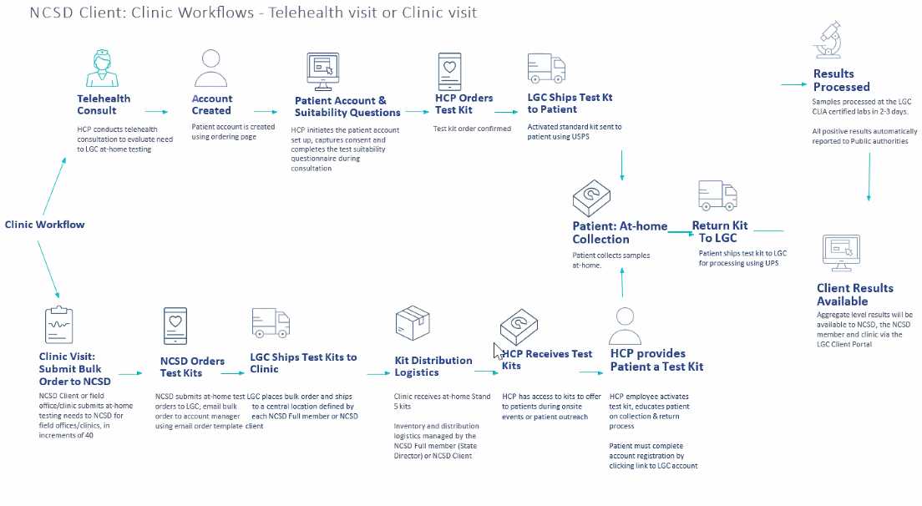

EXHIBIT 4 (Continued)

WORK FLOW EXHIBIT

