**ARPA BROADBAND ACCESS GRANT APPLICATION PUBLIC/PRIVATE PARTNERSHIP AGREEMENT WISCONSIN STATE STATUTE §196.504**

This Public/Private Partnership Agreement ("Agreement") is made by and between the County of Sauk, a Wisconsin municipal corporation (the "County") and River Valley Commons, a Wisconsin non-profit corporation ("'RVC"). The County and RVC are individually referred to as '· Party' · and collectively referred to as "Parties'·.

WHEREAS, the County seeks to help provide access to broadband services in unserved and/or underserved areas and to encourage economic development within its boundaries; and

WHEREAS, RVC proposes to encourage the expansion of broadband in the River Valley School District geographic area (shown in Exhibit A) by undertaking the activities included in Exhibit B ("the Project");

WHEREAS, the County is a political subdivision of the State of Wisconsin; and WHEREAS, the County desires to enter into this Agreement to work with RVCto

encourage broadband expansion; and

WHEREAS, at the {date} County Board meeting, the Board voted to proceed with RVC and the proposed joint broadband Project between the County and RVC, and to contribute an amount of $15,600.00 to support the work outlined in Exhibit B; and

WHEREAS, the County will assist in public education, outreach, and mutually agreed upon operations in support of successful Project outcomes.

WHEREAS, enhanced broadband access and availability will be utilized to position the County for desirable economic growth through addressing existing service disparities, while providing a means for accessing the advantages of technology-based economic development practice for the subject localities.

NOW, THEREFORE, the Parties agree as follows:

I. Purpose. The Parties agree to cooperate and exercise their powers jointly for the purpose of providing support and/or revenues for the Project - Exhibit A includes a map showing the Project area, and Exhibit B contains the activities RVC will undertake to support broadband expansion in the area.

1. Authorization. Each Party shall authorize the execution, delivery,and performance of this Agreement and authorizes RVC, as an agent, to execute any other agreements requested to be executed and delivered hereunder, as an agent for the Parties.
2. Project Funding. The County has agreed to provide a contribution of the County's ARPA funding in the amount of $15,600.00 to the cost of the Project, to be paid as provided in section 4 below. RVC, directly and through other sources, will provide the balance of the funding for the Project.
3. Payment to RVC. The County shall pay the amount of $15,600.00 as follows:

October 1, 2021 $7,800.00

April 1, 2022 $7,800.00

1. Project Ownership: RVC shall have sole ownership of the Project and shall be solely responsible for operation of the Project.
2. Liability: RVC shall have sole liability for the Project and any and all claims, obligations, liability, costs. demands, damages, expenses, fines, penalties, or causes of action (""Claims'") that ma) arise from the Project. RVC and its successors and assigns shall indemnify and hold the County and its officials. employees, and agents harmless from any and all Claims, including the costs of litigation and reasonable attorney's fees which may arise out of the operation of the Project.
3. Records: RVC will maintain records related to the Project; and, during the Project, RVC will make those records available upon reasonable request of the County.
4. Report: Until completion of the project, RVC shall meet with the County on a semi-annual basis for the purpose of presenting an oral report on the status of the Project. The date, time and place of such meeting shall be determined cooperatively among the Parties. No less than seven (7) days prior to such meeting RVCshall provide a written report regarding progress with respect to the Project.
5. Effective Date. This Agreement shall become effective upon October 1, 2021.
6. Termination Date. This Agreement will terminate one year after the effective date.
7. Amendments. Any amendments to this Agreement must be in writing and signed by the Parties.
8. Entire Agreement. This Agreement, including its recitals and exhibits constitutes the entire Agreement and understanding of the Parties with respect to the subject matter of this Agreement. There are no representations or understandings of any kind not stated in this Agreement.
9. Governing Law. This Agreement shall be governed by the laws of the State of Wisconsin.
10. Counterparts. This Agreement may be executed in two or more counterparts each of which shall be deemed an original but all of which together shall constitute one and the same instrument.

**EXHIBIT A**River Valley School District   
Geographic Area

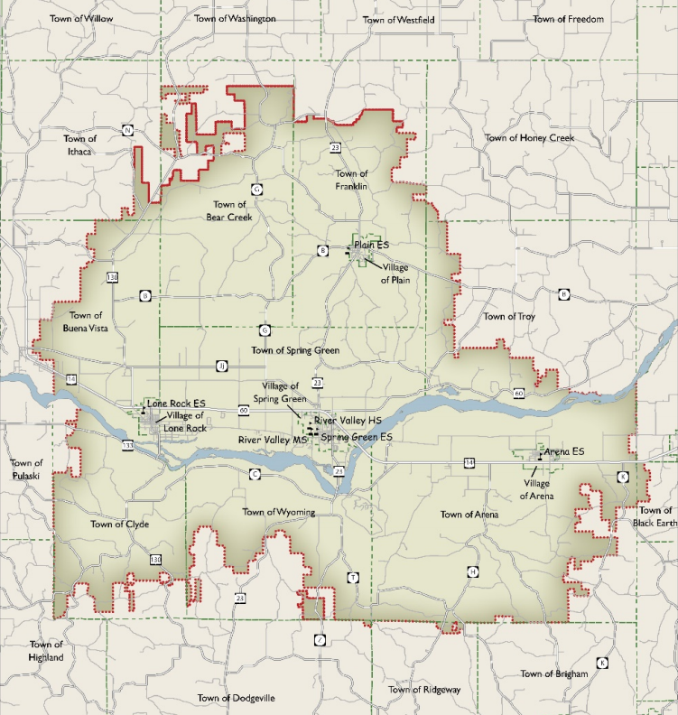

**EXHIBIT B**Project Activities

**For a period of one year, RVC will:**

* Coordinate the River Valley Broadband Coalition. Provide meeting agendas and notes. Prepare data or other materials needed for discussions.
* Meet with municipalities within the RVSD geographic area to share information and broadband funding opportunities. Provide direction and guidance to municipalities as they prepare funding requests and market broadband opportunities to their communities. Act as a resource and connector for municipalities as they expand broadband.
* Develop & maintain a digital navigator program that provides residents of the RVSD geographic area with access to community volunteers who will train and assist in internet adoption and the use of computing devices.
* Research funding opportunities, assist with grant processes, and provide support in securing funding for broadband expansion.
* Provide educational opportunities for the public about broadband, including information about policies, funding, and broadband expansion in the area.
* Market broadband rollouts, data-gathering activities, and other projects that may benefit broadband expansion in the RVSD geographic area**.**