**485-022**

**MEMORANDUM OF UNDERSTANDING**

**THIS MEMORANDUM OF UNDERSTANDING** (“MOU”), made and entered into on _______________________, by and between, Sauk County (SC), whose address is 505 Broadway, Baraboo, Wisconsin 53913 and the STATE OF WISCONSIN, DEPARTMENT OF ADMINISTRATION (“DOA”). At all times, this MOU shall be subject to the mandatory terms and conditions for state occupied/leased premises, attached hereto as **Exhibit A**;

**WITNESSETH,** the parties hereto for the considerations hereinafter mentioned covenant and agree as follows:

1. **PREMISES.** SC hereby agrees to provide the following space to DOA (the “Premises”):

Approximately 196 square feet of office space in SC’s building, together with all appurtenances and access to common areas, located at 505 Broadway, Room 205, in the City of Baraboo, Wisconsin (the “Building”), which Premises are further described in Exhibits B (aerial photo/site plan) & C (floor plan) attached.

1. **USE OF PREMISES.** Except as otherwise authorized in writing by SC, DOA shall use the Premises as space for the Department of Veterans Affairs or such other agency that may be designated by DOA (collectively, the “Tenant”).
2. **TERM.** The MOU term hereunder shall begin on July 1, 2021 and end on June 30, 2022 (1 year). In addition, the MOU includes two 1-year renewal options.
3. **INITIAL TERM CONSIDERATION.** DOA shall pay SC consideration for the Premises of Zero And 00/100 Dollars ($0.00).
4. **RENEWALS.** Provided that DOA is not then in default, this MOU may, at the option of DOA, be renewed for two successive 1-year periods from and after July 1, 2022, upon the same terms and conditions herein specified, provided written notice be given to SC at least 60 days before the MOU would otherwise expire.

IN WITNESS WHEREOF, the parties have subscribed their names as of the date of the last signature below.

OWNER:

Sauk County

By: _______________________________________________

Signature

_______________________________________________

Print Name and Title

# Dated: ____________________________________________

State of Wisconsin

Department of Administration (DOA)

By: ______________________________________________

CHRIS PATTON

DEPUTY SECRETARY

DEPARTMENT OF ADMINISTRATION

Dated: ___________________________________________

File No. 485-022

**Schedule I**

SC, **at SC’s** **cost**, upon reasonable request, shall furnish to DOA during the term of this MOU, as part of the consideration, the following:

1. The environmental control system shall maintain a comfortable humidity level and temperatures for an estimated use of 60 hours per week as follows:

Summer Winter

76 Degrees (+/- 2o) 70 Degrees (+/- 2o)   
50% Humidity Level (+/- 10%) 25% Humidity Level (+/- 5%)

The temperature range during unoccupied times (generally 6 p.m. to 6 a.m.) may be varied by up to +/- 10o of the above temperatures.

1. Provide, maintain and service heating, air conditioning, plumbing and ventilating equipment as per manufacturers and/or installers recommendations.
2. Install and maintain fire extinguishers according to any governmental building code and Underwriters Laboratories (UL) recommendations.
3. Provide safe drinking water with hot and cold running water for restrooms, counter sinks and janitorial facilities. Such drinking water shall meet minimum State of Wisconsin Drinking Water Quality Standards.
4. Provide 2 access keys and cards to building and office space.
5. Provide Water and Sewer & Heat and Air Conditioning.
6. Provide electricity for lights and other electrical equipment necessary for operation of the Premises.
7. Furnish, install and replace during the term of this MOU and any extension thereof, light bulbs, fluorescent tubes, starters, ballasts or transformers.
8. Furnish building occupancy or use permit(s) if required.
9. Furnish all necessary janitorial and maintenance equipment and supplies for restrooms including soap, towels and toilet tissue.
10. SC is to provide all services, supplies and equipment required to clean and keep clean all areas of the building, sidewalks, parking areas, and grounds. This includes, but is not limited to, the plowing and removal of snow, ice removal and salting, removal of trash, and pest control.
11. Provide sufficient onsite parking.
12. Provide snow and ice control and removal. Snow and ice will be removed from designated walking surfaces on SC controlled parking lots and sidewalks on building grounds.

**EXHIBIT A – MANDATORY TERMS AND CONDITIONS FOR STATE LEASED PREMISES**

1. **ASSIGNMENTS.** DOA shall not assign this MOU in any event and will not permit the use of said Premises by anyone other than Tenant, and the agents, contractors, grantors and grantees, and servants of Tenant, without prior written approval of SC, which shall not be unreasonably withheld.
2. **COVENANTS OF SC.** SC hereby covenants and agrees with DOA as follows:
3. SC warrants that DOA shall have quiet use and enjoyment of the Premises; that SC has complete interest, right in and title to the Premises so as to enable SC to enter into this MOU; and that the Premises is not encumbered in any way so as to hinder or obstruct DOA’s proposed use thereof, including no encumbrance or obstruction due to existing easements, zoning ordinances or building restrictions.
4. SC shall duly carry out the various obligations and duties imposed upon it at the time and in the manner called for by this MOU.
5. SC shall furnish during the term of this MOU the goods, services and other items listed on **Schedule I**, attached hereto and incorporated by reference.
6. In connection with any performance of work under this MOU, SC agrees not to discriminate against any employee or applicant for employment because of age, race, religion, color, handicap, sex, physical condition, developmental disability as defined in s. 51.01(5), sexual orientation, or national origin. This provision shall include, but not be limited to, the following; employment, upgrading, demotion, or transfer; recruitment or recruitment advertising; layoff or termination; rates of pay or other forms of compensation and selection for training, including apprenticeship. Except with respect to sexual orientation, SC further agrees to take affirmative action to ensure equal employment opportunities. SC agrees to post in conspicuous places, available for employees and applicants for employment, notices to be provided by DOA, setting forth the provisions of this non-discrimination clause.
7. Pursuant to 2019 Wisconsin Executive Order 1, SC agrees it will hire only on the basis of merit and will not discriminate against any persons performing under a contract, subcontract or grant because of military or veteran status, gender identity or expression, marital or familial status, genetic information or political affiliation.
8. SC as part of this MOU certifies that to the best of its knowledge both the Premises and the building of which the Premises are a part do not contain any asbestos bearing material which is unsafe, or which is not encapsulated.
9. SC attests that space covered by this MOU is not owned by a state public official or state employee as defined in section 19.45, Wisconsin Statutes and Chapter ER-MRS 24 of the Wisconsin Administration Code, nor is SC a business in which a state public official or state employee has any ownership, monetary or fiduciary interest.
10. For the purposes of this MOU, Hazardous Materials, Substances, or Air Pollutants (“HMSAPs”) shall include, but not be limited to any, and all substances, materials, waste, or air pollutants determined currently or in the future as hazardous or capable of posing a risk of injury to health, safety, or property by any Federal, State, or local statute, law, ordinance, code, rule, regulation, order, or decree. SC attests that the Premises is free of any HMSAPs and that SC will now and forever after the termination of this MOU, hold DOA harmless and indemnify DOA from and against any and all claims, liability, damages or costs arising from or due to the presence of HMSAPs except liability resulting from DOA’s use and occupancy of the Premises.
11. The default by SC of any covenant or agreement contained in any paragraph or provision of this MOU shall constitute a material default of the MOU and shall entitle DOA to terminate this MOU.
12. SC shall be responsible for paying to taxing authority the real estate taxes and any assessments on the Premises.
13. **COVENANTS OF DOA.** DOA hereby covenants and agrees with SC as follows:
14. DOA does hereby covenant, promise, and agree to duly comply with all other provisions of this MOU at the time and in the manner herein provided.
15. At the expiration or termination of this MOU or any renewal thereof, DOA will return the Premises to SC in as good condition as it was at the time DOA went into possession, ordinary wear, damage by the elements and fire excepted. It is mutually agreed that DOA shall not be responsible for damage to the Premises by fire.
16. DOA will not make or permit anyone to make any alterations, improvements or additions in or to the Premises, without the prior written consent of SC.
17. If DOA shall be late in the performance or observance of any covenant or obligation in the MOU or if DOA fails to cure said late performance or observance within thirty (30) days after receipt of notice from SC (unless DOA commences to cure said late performance or observance within (30) days after receipt of notice thereof and expedite the curing of the same to completion with due diligence), then SC may terminate this Lease by providing DOA with five (5) days written notice.
18. DOA agrees that any improvements to the Premises made by SC for the benefit of DOA shall be the property of SC. Such improvements exclude any of DOA’s system furniture, conventional furniture and all other DOA personal property.

1. **INSURANCE.** Unless SC is a self-insured government entity, SC agrees to procure and maintain, during the term of this MOU, property and casualty insurance for the building containing the Premises. SC also agrees, if requested by DOA, to procure and maintain, during the term of this MOU, commercial general liability insurance in the amount of not less than **$1.0 million each occurrence and $2.0 million general aggregate**. Under all conditions noted above, general aggregate limits are to apply on a per location basis. In addition, SC shall provide upon signing of the MOU and thereafter annually, a Certificate of Insurance to DOA evidencing such coverage by date of occupancy. The State of Wisconsin Self-Funded Liability and Property Programs protects DOA. Wisconsin Statutes provide funds to pay property and liability claims.
2. **HOLD HARMLESS.** SC agrees to protect, indemnify and save the State of Wisconsin harmless from and against any, and all claims, and against any and all loss, cost, damage or expense, including without limitation reasonable attorneys’ fees, arising out of any negligent acts of Lessor its invitees or agents, or any failure of SC in any respect to comply with and perform all the requirements and provisions of this MOU.
3. **TERMINATION.** DOA may terminate this Lease at any time during the initial term or any renewals thereof by providing SC with fifteen (15) days written notice.
4. **NOTICES.** Notice in writing referred to herein shall not be construed to mean personal notice, but such notice shall be given in writing, by mail, by depositing the same in the post office or letter-box, in a postpaid envelope, addressed to SC at SC’s last known address, and such notice shall be deemed to be given at the time when the same shall be thus mailed. Such notices provided hereunder shall be addressed as follows:

If to SC: Tony Tyczynski

Sauk County

505 Broadway

Baraboo, WI 53913

If to DOA: State Leasing Officer

Wisconsin Department of Administration

101 E. Wilson Street, 7th Floor

P.O. Box 7866

Madison, WI 53707-7866

1. **BROKERS.** SC and DOA represent and warrant to each other that they have had no dealings with any broker or agent in connection with this MOU and SC agrees to pay, and hold DOA harmless from, any claims made by anyone for any compensation, commissions and charges claimed with respect to this MOU or the negotiations thereof.
2. **HOLDING OVER.** If DOA holds over after the term hereof, with or without the express written consent of SC, such tenancy shall be from month to month only, with no renewal hereof or an extension for any further term, and monthly consideration shall be zero dollars ($0.00). Such month-to-month tenancy shall be subject to every other term, covenant and agreement contained herein.
3. **DOA COSTS.** It is not anticipated that tenant will incur phone and data costs for the Premised; however, in the event there is such use, DOA shall be responsible for the monthly phone and data costs for the Premises.
4. **CAPTIONS.** The item captions contained herein are for convenience only and do not define, limit, or construe the contents of such items, paragraphs, or sections.
5. **AUTHORIZATION, BINDING EFFECT.** This MOU, together with all amending instructions subsequent thereto, is not valid or effective for any purpose until approved by the Governor or his delegate, the Secretary of the Department of Administration.
6. **WAIVER.** The rights and remedies of either party under this MOU, as well as those provided or accorded by law, shall be cumulative, and none shall be exclusive of any other rights or remedies hereunder or allowed by law. A waiver by either party of any breach or breaches, default or defaults, of the other party hereunder shall not be deemed or construed to be a continuing waiver of such breach or default nor as a waiver of or permission, expressed or implied, for any subsequent breach or default.
7. **CHOICE OF LAW.** This MOU shall be governed by and construed and interpreted in accordance with the laws of the State of Wisconsin.
8. **EXECUTED MOU.** This MOU when fully executed shall be binding upon the respective heirs, executors, administrators, successors, and assigns of the parties hereto.
9. **ENTIRE AGREEMENT.** This MOU constitutes the entire agreement between the parties with respect to its subject matter and constitutes and supersedes all prior agreements, representations and understandings of the parties, written or oral.

**EXHIBIT B – AERIAL PHOTO / SITE PLAN**

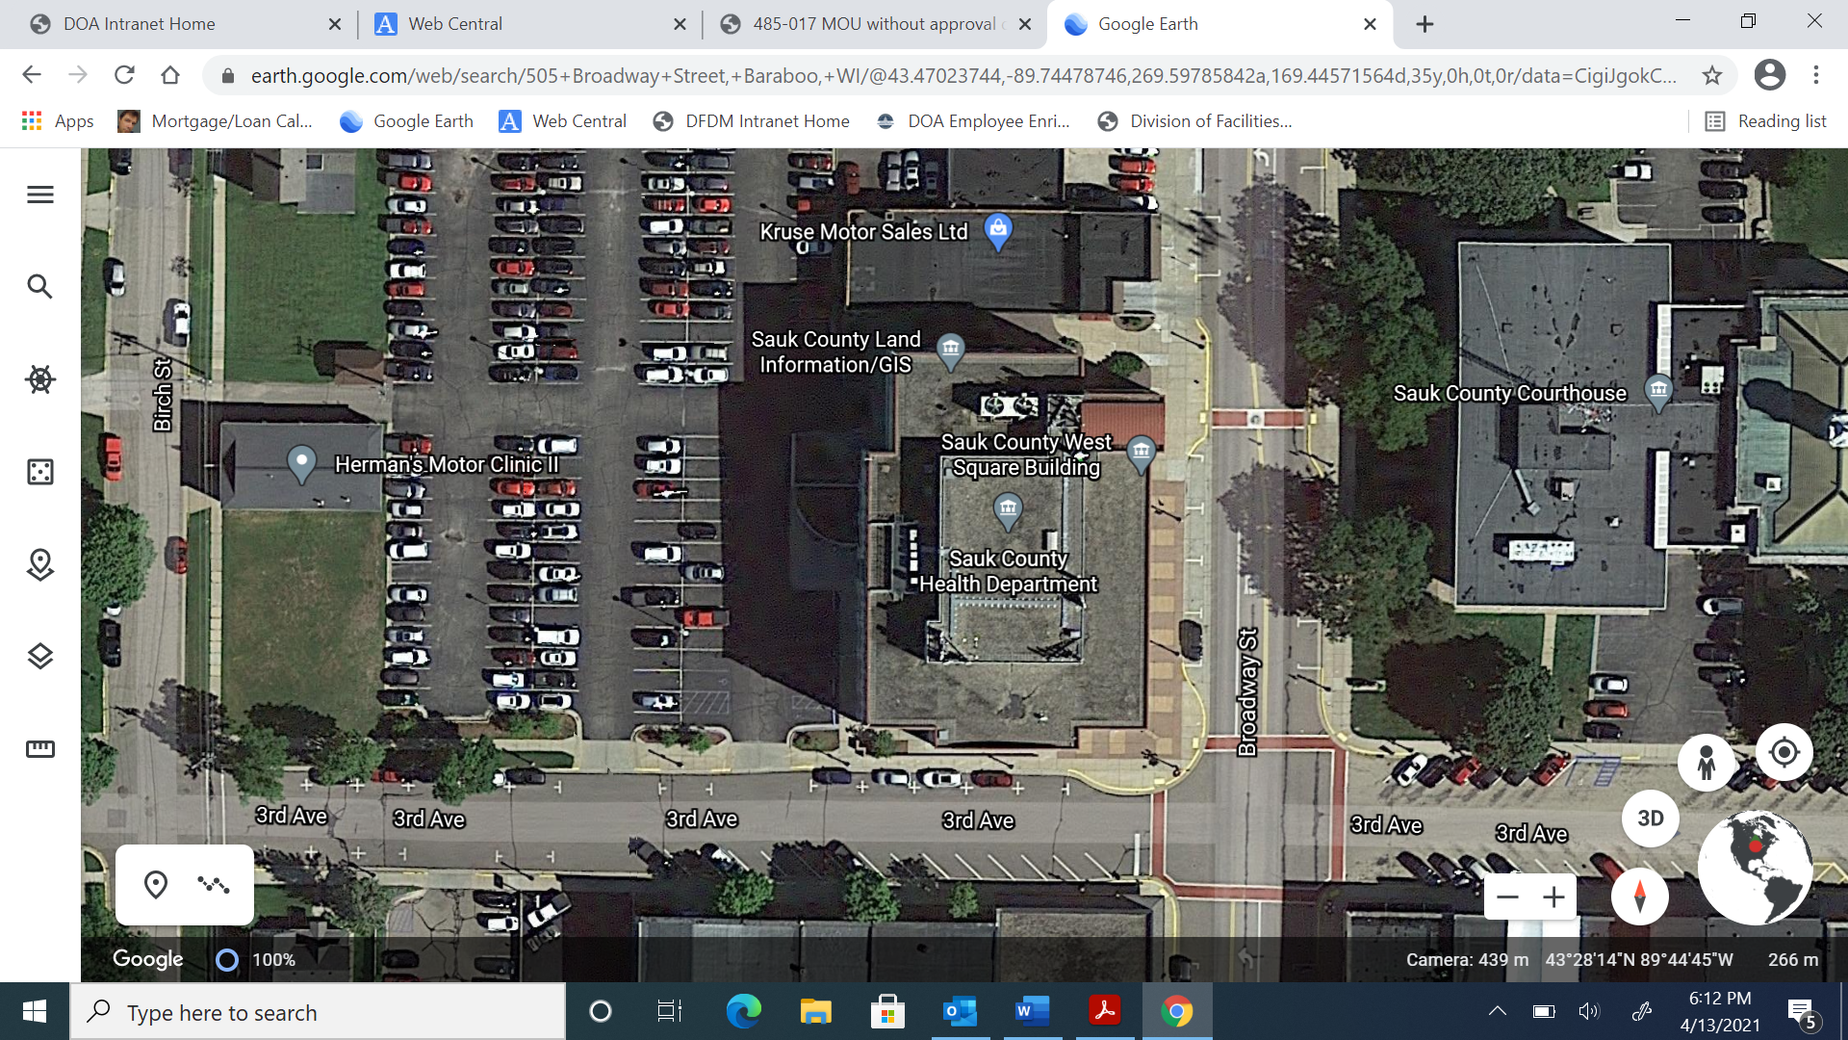

**EXHIBIT C – FLOOR PLAN**

**(TBD)**