
1937 Piperton Lane, Knoxville, TN 37931 - 865-742-4690 - SAStrutner@gmail.com

Memorandum of Understanding
Between Sauk County Partnership for Prevention and
Evaluator, Stephanie Strutner, MPH, CPSII

Stephanie Strutner, MPH, CPSII will fully support Sauk County Partnership for Prevention evaluation program by providing evaluation services for the project period. By combining our resources, we will work toward reducing youth substance use and will build upon community relationships so as to improve the health and safety of the residents of Sauk County.

With advanced knowledge of evaluation design and implementation, Mrs. Strutner will work with the Coalition to develop an evaluation plan tailored to suit the Coalition’s logic model. Mrs. Strutner also has analysis experience and will provide all analysis services deemed appropriate by the Coalition.

Responsibilities of the evaluator include:

- Customize an evaluation plan to meet the Coalition’s logic model and action plan and update the plan annually, or more frequently if the need arises, to systematically evaluate all components of coalition activities parallel to input DFC Me and to measure Coalition progress and population-level behavior change;
- Create a customized database for data entry;
- Review coalition records monthly;
- Provide an ongoing review of program data as provided by the Project Coordinator;
- Actively participate in and lead annual reviews and evaluations;
- Provide consultation and recommendations for data collection including design of pre- and post-test surveys;
- Analyze assessments, data collected, programs, coalition effectiveness, and impact, process, and outcome measures as outlined in the action plan;
- Provide a formal, written evaluation annually on coalition progress toward set objectives, as outlined in the action plan;
- Provide quarterly reports based on data submitted through the Coalition’s customized database;
- Draft, provide in electronic form, evaluate, and report biennial core measures survey;
- Utilize local statistical measures required by the DFCS program to observe trends in use (including, but not limited to GPRA measures), utilizing cultural competency standards to ensure materials are understandable to the majority of the population;
- Make recommendations based on evaluation findings, incorporating formative evaluation in addition to process and outcome evaluation to monitor progress throughout the project period to maximize effectiveness and lead to sustainability;
- Present evaluation findings as deemed appropriate by the Coalition; and
- Facilitate development of measureable outcomes.

The aforementioned services will be provided Sauk County Partnership for Prevention and will be paid upon the following schedule pending DFC grant funding:

- $12,500 paid in full upon for year one, due upon execution of MOU (if using survey option; $10,000 without survey)
- $12,500 annually (if using survey option; $10,000 without survey), paid in quarterly increments upon invoice in the amount of $3,125 for subsequent years (or $2,500 quarterly increments without survey)

This agreement will remain in effect through the end of the project period of September 30, 2031 unless terminated in writing by mutual agreement.

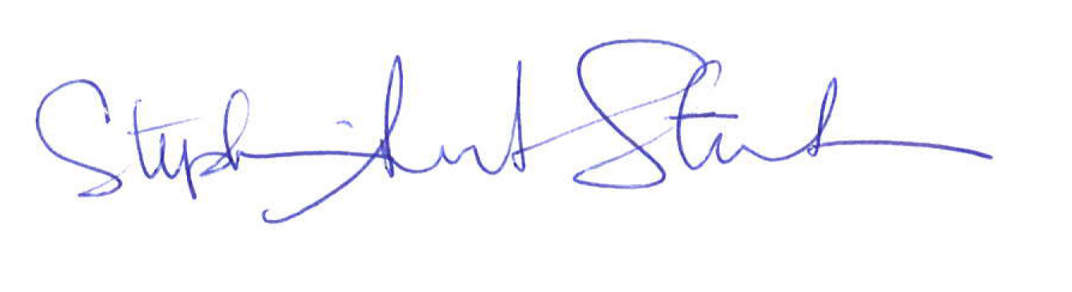
_______________________________ _______________________________
Stephanie Strutner, MPH, CPSII Sara Jesse
President Sauk County Partnership for Prevention

_4/5/21_______________________ _______________________________
Date Date

