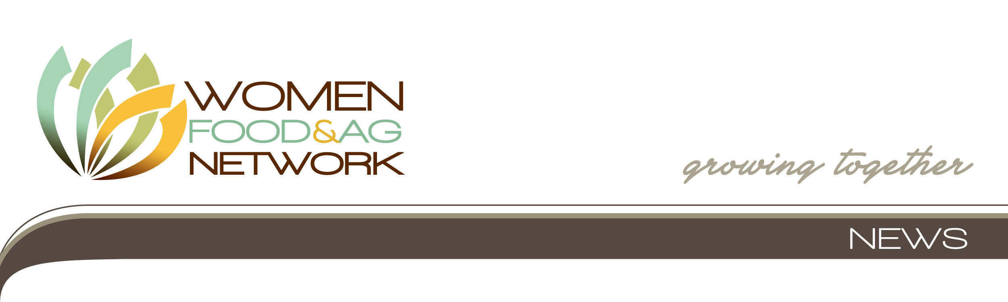
July 8, 2013 – FOR IMMEDIATE RELEASE
CONTACT: Lynn Heuss, 515.201.9405, or Penny Pohle, 608.355.4839

WOMEN FARMLAND OWNERS IN SOUTH CENTRAL WISCONSIN INVITED TO FREE CONSERVATION DISCUSSION AND FIELD TOUR JULY 19 IN BARABOO

AMES— Women who own or manage farmland in and around Sauk County, Wisconsin, are invited to a free conservation discussion and field tour on Friday, July 19, at the West Square Building, Meeting Room B-30, 505 Broadway, Baraboo, WI. Coffee and registration begin at 8:30 a.m. This event includes a discussion and lunch at the West Square Building, a bus tour of local conservation sites, and dessert and wrap-up back at the West Square Building no later than 3:30 p.m.

Space is limited. Please RSVP by 5 p.m. Tuesday, July 16, to Penny Pohle, Sauk County Conservation, Planning and Zoning, at ppohle@co.sauk.wi.us or (608) 355-4839.

Women now own or co-own nearly half of Midwest farmland, and an increasing number of women are now managing land inherited from their family or spouse. Many women landowners have questions about tenant oversight, soil and water quality, conservation goals, and professional resources. Women Caring for the LandSM is a program of Women, Food and Agriculture Network designed to help women landowners and managers talk about their individual land stewardship goals. The program offers a peer-to-peer, informal discussion format facilitated by female conservation experts who can explain resources available such as USDA cost share program, loans, leases, and other tools.

This event is sponsored by Women, Food and Agriculture Network as part of its Women Caring for the Land series, in collaboration with the Wisconsin USDA-NRCS, USDA-FSA, Sauk County UW-Extension
Sauk County Conservation, Planning and Zoning, and the MOSES Rural Women's Project. Funding for this meeting is provided by a grant from the McKnight Foundation.

"If I'd have known it would be so interesting, I would've brought a lot of friends along,” said one participant. Another said, “Thank you for explaining things in a way I could understand.”

WFAN is a non-profit organization providing networking, education and leadership development opportunities for women engaged in all aspects of sustainable agriculture. Visit www.wfan.org. For more conservation information from WFAN for women farmland owners, visit the program’s website, www.womencaringfortheland.org.

-30-

